How to Write a Project Proposal

When you are planning a project that involves stakeholders or financial backing, it is important to write a project proposal with clearly stated goals, activities that you will provide to meet these goals, needs for resources and your plans for obtaining there resources. Use the LOGIC MODEL, and the following format to organize your proposal and ask yourself the following questions to organize your thoughts.
- Who is your audience and who will be reading this proposal?
- Why are you doing this project?
- Who will be doing it?
- Where will it be done?
- How long will it take?
- How much will it cost?

Use the following format to organize your proposal:

Introduction: Provide a brief description of your project.

Proposal or Executive Summary: This section provides an overview of the project. Describe the plan of action, overall approach (how are you going to complete project), its relevance (why you believe this needs to take place), and the project’s innovation (why you believe that your project will work). Describe the population being served, and how you will manage anticipated barriers (e.g. student population low in summer, weak partnership relations). This is a long summary of your project that describes what your project’s ultimate goal is and how your project will make an impact.

Inputs (Resources): This section describes what resources are available and what resources are needed for your project (e.g. time, volunteers, materials).

Outputs (Activities): This section describes what activities will support the goal of your project (e.g. services, training, member development).

Timeline: Compile tasks and assign completion dates. Often this includes a milestone chart.

Budget (if needed): List the expenses in a line item budget. Include travel, supplies and equipment needed. Supply matching or indirect cost if applicable.

Conclusion (Outcomes): This section describes your intended outcome(s) of your project. How will the project benefit your community? What are the knowledge and skills gained from your project? What are the impacts of your project?
Project Plan
(Using the Logic Model)

Objective
Impact
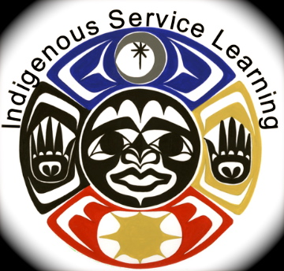
Reflection
Great Stories

Outputs
Activities, Training, Service

Timeline
Dates & Goals

Inputs
Resources Needed

