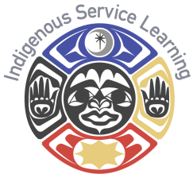
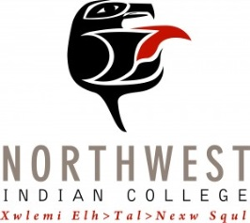
Center for Indigenous Service Learning
Community Partner Interest Form

Please complete this form (you may use additional pages) and return it to:
Director of Indigenous Service Learning
Attn: Ane Berrett
2522 Kwina Road
Bellingham, WA 98226

Phone: (360) 392- 4213
Fax: (360) 594-4084
Email: aberrett@nwic.edu

Agency/Organization Name: _______________________________________________

Agency/Organization Address: _____________________________________________
________________________________________________________________________
________________________________________________________________________

Contact Name: __________________________________________________________
Contact Phone: ________________________ Contact Email: ____________________

Please briefly describe the mission of your organization and the services you provide to the community:
________________________________________________________________________
________________________________________________________________________
________________________________________________________________________
________________________________________________________________________

Please briefly describe the program(s) or project(s) for which you are seeking service learning partnership, and the need that will be filled by our students:
________________________________________________________________________
________________________________________________________________________
________________________________________________________________________
________________________________________________________________________
________________________________________________________________________

If you do not have a project in mind at the moment, but would be interested in our
office contacting you with service-learning ideas in the future, please indicate that here:

Thanks you for your interest! We will contact you shortly with more information.

