FACULTY MANUAL
for
The Center for Indigenous Service Learning

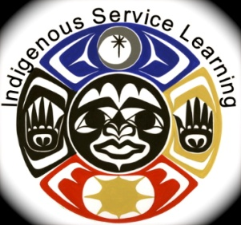

Table of Contents

- What is Indigenous Service Learning?

- Opportunities to Service

- Course Development Worksheet

- Reflection Guide

- Community Partner Interest Form

- Service Learning Project Plan and Agreement

- Student ISL Hour Report

- Data Collection Form

- Photo/Testimonial Release Form

- Project Plan Worksheet

- How to Write a Project Proposal

The Center for Indigenous Service Learning
Contact Info

Ane Berrett, Director of ISL
aberrett@nwic.edu
(360) 392-4213

www.nwic.edu

www.facebook.com/NWICISL

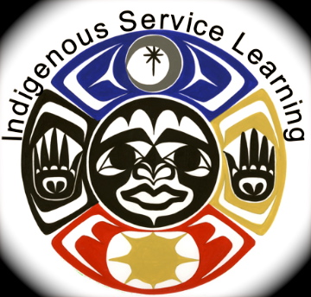
Mission Statement: The Center for Indigenous Service Learning at Northwest Indian College supports experiential learning to sustain people, communities and the natural world.
What is Indigenous Service Learning?
Indigenous Service Learning promotes experiential learning to sustain the connections of people, place, and the natural world. Northwest Indian College strives to embed these values of Indigenous Service Learning across the college curriculum beginning with FYE courses all the way through culminating four year projects. Within the course objectives, students will learn to identify a relevant community need, interact with community partner(s), develop and participate in a project varying from 5-15 hours, meet the community needs within or outside of designated class time, and prepare a class presentation which encourages reflective and critical thinking about the impact of the project on students, partners, and the community. Indigenous Service Learning provides students with the opportunities to deepen academic knowledge through practical application, leadership skills, and connection with people and place through reciprocal relationships of care and service.
At Northwest Indian College, the world is our classroom and through service we are planting the seeds of change for future generations.

Opportunities to Serve

ISL Leadership & Service Scholarships

Pending available funds students may have an opportunity to earn a leadership and service scholarship. This scholarship is awarded to a student who has provided service and leadership through developing and implementing a relevant project within their community. One can apply for the leadership and service scholarship at the Center for Indigenous Service Learning (ISL). The student must complete an application and project plan, and then interview with ISL staff. Once approved the student is matched with a viable community partner and assigned a certain number of service hours. When the service hours and project are completed the student earns an education award. This is a great opportunity for students to make a difference in their communities, gain valuable civic and workforce skills, and earn a scholarship for their education.

Monthly ACT Events (Aligning Communities for Tomorrow)

The Center for Indigenous Service Learning hosts a monthly community action event at Northwest Indian College, known as ACT days (Aligning Communities for Tomorrow). ACT’s objective is to get NWIC students off campus and into their community. ACT aims to embrace the cultural significance of each season, and plan an event to encompass these values. ACT was established to offer an opportunity for any student or community member to serve and honor their relations. In collaboration with Student Service a yearly calendar will be provided for faculty and students for advance planning with the goal of incorporating these events into class curriculum.

National Days of Service

The National Days of Service include MLK Jr. Day, Earth Day, Remembrance of September 11th, and Make a Difference Day. The Center for Indigenous Service Learning organizes service activities and educational awareness on the National Days of Service that take place during the academic school year.

Course Development Worksheet

How to set up your course to include Indigenous Service Learning

Dr. Greg Cajete’s educational process model* adapts a circle to each stage in the cycle of learning. It begins and ends with the student. This model can be adapted to develop and carry out a service learning project successfully in your classroom using this indigenous approach.
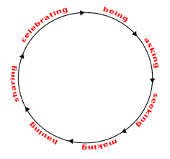
BEING: Opening to the learning process
- What is indigenous service learning?
- Where are you, your students and community in the process of implementing and collaborating on a service learning project?
- What gifts skills and talents do you all have to bring to the table?

ASKING: Creative exploration of course, student and community relevant needs
- Which of your courses or course learning objectives could be related to service?
- What are your student and community relevant needs?
- What do your students want to learn and gain from the experience?

SEEKING: Looking for meaningful answers and contacts
- Who are the campus or community partners you or your students need to contact and build relationship with to prepare for the project?
- What research, design, or interviews are needed?
- How will you prepare your students for the indigenous service learning projects?
- How is your project connected to the people and land of this place and how does it incorporate indigenous values?
- Can your project incorporate cultural occurrences of season and time of year?

MAKING: Making the vision concrete
Describe the service activities through which students will learn and/or apply the course objectives and outcomes.

- What project plan will you use to help students and partners design the plan?
(See logic model in packet as an example)
- Will you help students develop the service learning project plan and objectives?
- What strategies for critical thinking skills and reflection will you use?
- How will you purposely foster reciprocal relationships in this project?
- What time tables, deadlines, hours of service are needed to complete the plan?
- What tools are needed for student partner and instructor assessment, reflection and course credit?

(Credit relates to demonstrated learning, not simply putting in hours. Learning can be assessed via academic assignments that help connect the service experience with teaching/learning objectives. )

HAVING: Internalizing the learning (Outcomes of Service Learning)
How will you assess for basic service learning goals?
- Critical thinking skills –higher level of thinking and problem solving
- Commitment of civic engagement
- Meeting course objectives – in depth understanding of course material
- In-depth understanding of community needs

Application of indigenous values in an academic course
How will you assess for indigenous service learning goals?
Serving, sustaining and caring for one another in relational communities of people and place .

Did your project do the following?
- Demonstrate belief in the spiritual knowledge of the natural world
- Recognize responsibility for individual actions in the natural world and relational circles.
- Participate and collaborate in teams to meet relevant community needs
- Exhibit leadership skills through service, respect, gratitude and reverence for all life.
- Acknowledge joy, self-empowerment and a sense of belonging that comes through providing service.
- Sustain and honor intergenerational relationships and knowledge through service
- Reflect impact of service learning within circles of people and place
SHARING: Distributing information about the project
What reflection tools will you use?
Are your reflections on-going or at end of course? (e.g. readings, written assignments, journals, class discussions, presentations, guest speakers, creating educational materials, posters, videos, art etc.? See reflection section for more ideas)

CELEBRATING: Marking successful creation of the project
How will you honor students, community and campus partners for their participation in the project?

BEING: Bringing continuing life to the creation of the project through investment of the self.
This stage brings new insights and understanding as student return to the beginning of the circle.

* Roy, Loriene, and Peter Laresen. "An Indigenous Approach to Creating A Virtual Library of Education Resources." D-Lib Magazine 8.3 (2002)

Reflection Guide

“Reflection is a skill, more accurately a cluster of skills, involving observation, asking questions and putting facts, ideas, and experiences together to add new meaning to them all. Learning to learn in this way, and instilling the practice as a habit, can allow program experiences to live on in the students’ lives in new experiences and new learning”.
-Dan Conrad and Diane Hedin, Youth Service: A Guidebook for Developing and Operating Effective Program
Why Reflect?
Reflection is critical to the service learning process, since this is where a lot of the learning takes place. Reflection serves as a bridge for connecting what a student learns in class and what they are experiencing in the community. Reflection activities ignite a sense of ownership in the student, a better understanding of one’s own abilities, and a greater awareness of oneself.

When to Reflect:

Before: Course material provides stimulus to determine community or campus needs in order to focus the project around. Teach students to use the Project Planning Guide and Logic Model to clearly identify goals, resources, patners and activities, address potential problems and identify contingency plans.

During: Connection and application to course material and personal insights through opportunities for continual observation and analysis of the project.

After: Guided reflections promote increased civic engagement, awareness of community needs, deeper application of course material, increased indigenous knowledge and connection and individual development.

HOW TO REFLECT:

Telling
Storytelling remains one of the most important ways that humans transit information to each other and both the teller and the listener increase understanding from communicating and listening. Oral class presentations, honor, circles, electronic story telling though digital or power point media, art, collage, puppetry, drama, music all ways to tell the story.

Activities
Reflection through action can also offer some specific advantages in meaning-making. Often, these sorts of exercises speak to a variety of learning styles, help to develop groups, and allow forward momentum to be bilt into the project. Case studies, interviewing classmates, class discussions, role playing, drama, art are some examples of engagement through action.

Writing
There are numerous strategies to design a writing assignment and have some advantages over other reflection modes. They provide an opportunity to refine writing skills, challenge the students to organize their thoughts, and generate a permanent record of the service experience. Portfolios, guided and directed assignment, or journal entries are some examples.

Sharing and honoring the circle
Reflecting at the closure of the service project in a circle provides a unique opportunity for students to share their experience with one another. It also is a great opportunity to express gratitude and thanks.

A FINAL NOTE: The 4 C’s of Successful Reflection
Continuous: Reflection must take pace before, during and after the completion of the service project to be fully useful

Challenging: Effective reflection involves pushing ourselves out of our comfort zones to make new connections between concepts and to think in new ways
Connected: Successful reflection can serve as a bridge between the service experience and our discipline-based academic knowledge

Contextualized: Effective reflection is framed in a manner that is appropriate for the context in which the service experience takes place.

Cress, Christine, Peter Collier, and Vicki Reitenauer. Learning through Serving. Sterling: Stylus, 2005

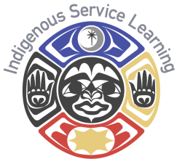
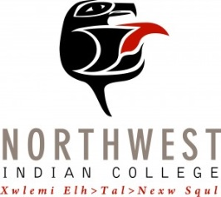
Center for Indigenous Service Learning
Community Partner Interest Form

Please complete this form (you may use additional pages) and return it to:
Director of Indigenous Service Learning
Attn: Ane Berrett
2522 Kwina Road
Bellingham, WA 98226

Phone: (360) 392- 4213
Fax: (360) 594-4084
Email: aberrett@nwic.edu

Agency/Organization Name: _______________________________________________

Agency/Organization Address: _____________________________________________
________________________________________________________________________
________________________________________________________________________

Contact Name: __________________________________________________________
Contact Phone: ________________________ Contact Email: ____________________

Please briefly describe the mission of your organization and the services you provide to the community:
________________________________________________________________________
________________________________________________________________________
________________________________________________________________________
________________________________________________________________________

Please briefly describe the program(s) or project(s) for which you are seeking service learning partnership, and the need that will be filled by our students:
________________________________________________________________________
________________________________________________________________________
________________________________________________________________________
________________________________________________________________________
________________________________________________________________________

If you do not have a project in mind at the moment, but would be interested in our
office contacting you with service-learning ideas in the future, please indicate that here:

Thanks you for your interest! We will contact you shortly with more information.

How to Write a Project Proposal

When you are planning a project that involves stakeholders or financial backing, it is important to write a project proposal with clearly stated goals, activities that you will provide to meet these goals, needs for resources and your plans for obtaining there resources. Use the LOGIC MODEL, and the following format to organize your proposal and ask yourself the following questions to organize your thoughts.
- Who is your audience and who will be reading this proposal?
- Why are you doing this project?
- Who will be doing it?
- Where will it be done?
- How long will it take?
- How much will it cost?

Use the following format to organize your proposal:

Introduction: Provide a brief description of your project.

Proposal or Executive Summary: This section provides an overview of the project. Describe the plan of action, overall approach (how are you going to complete project), its relevance (why you believe this needs to take place), and the project’s innovation (why you believe that your project will work). Describe the population being served, and how you will manage anticipated barriers (e.g. student population low in summer, weak partnership relations). This is a long summary of your project that describes what your project’s ultimate goal is and how your project will make an impact.

Inputs (Resources): This section describes what resources are available and what resources are needed for your project (e.g. time, volunteers, materials).

Outputs (Activities): This section describes what activities will support the goal of your project (e.g. services, training, member development).

Timeline: Compile tasks and assign completion dates. Often this includes a milestone chart.

Budget (if needed): List the expenses in a line item budget. Include travel, supplies and equipment needed. Supply matching or indirect cost if applicable.

Conclusion (Outcomes): This section describes your intended outcome(s) of your project. How will the project benefit your community? What are the knowledge and skills gained from your project? What are the impacts of your project?
Project Plan
(Using the Logic Model)

Objective
Impact
Reflection
Great Stories

Outputs
Activities, Training, Service

Timeline
Dates & Goals

Inputs
Resources Needed

Student Project Plan
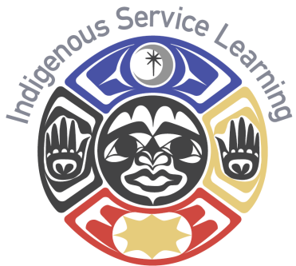
Using the Backward design for project planning create a skeleton for your service learning project
Project Outcome: What will be your end result? What is your ultimate goal? How and who will your project impact?

Inputs: What do you need to make this project a success? (I.E. resources, finances, training) Is there anyone else involved? (I.E. volunteers, faculty, partnerships)

Timeline: Create a time line to help you stay on track and ensure you are meeting your goals.

Outputs: What are your specific responsibilities? Where do these responsibilities fit on your timeline?

Reflection: Write a reflection on your project. What did you learn? What worked and what didn’t? What challenges did you face? Who did you impact with your project?

Please give a copy of your reflection to your teacher and the Center of Indigenous Service Learning.
Be sure to keep track of your hours, from research to reflection. We want to ensure you are credited for every bit of your hard work.
Date | Task | Number of Hours

Photo/Reflection Release: I give Northwest Indian College permission to use my name, reflection, photos, or digital media of me and my project for publicity, recruitment or fund raising to support college programs to promote student success.

________________________________ _____________
Signature Date

Thank you for, supporting, setting an example, and preforming this service for your community and future generation!

Course and Quarter: __________________________________ Please return to the Center of Indigenous Service Learning at
Instructor Name: __________________________________ the end of each quarter or end of your project. Please attach
Community Partner: __________________________________ student reflections if you use this form.
Service-Learning Site:_________________________________

 |  |  | Check All That Apply
 | Students Name | # Of Service Hours | College Student | Middle/High School Student | Non-Student/ Community Member | Baby Boomer (Born Between 1946-1964)
1.
2.
3.
4.
5.
6.
7.
8.
9.
10.
Total.

Native Leadership
Way of life
Inherent Rights
Community-Minded
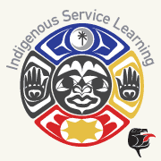

Indigenous Service Learning outcome: Cultivate and sustain the connections of people and place through community engagement and leadership.
CRITERIA | ACCOMPLISHED | DEVELOPING | BEGINNING
Academic Integration | Applies connections of service learning project to course and college outcomes. | Expresses some connection of service learning project to course and college outcomes. | Describes limited connection of service learning project to course and college outcomes
Community Needs | Determines community needs and applies tribal values of giving back through service | Demonstrates some awareness of community needs and giving back through service | Describes limited awareness of community needs and giving back through service.
Community Collaboration | Supports team engagement to advance the collective good of the community and work toward solutions. | Applies some team engagement to advance the collective good of the community and work toward solutions. | Demonstrates limited team engagement to advance the collective good of the community and work toward solutions.
Indigenous  Leadership | Applies Indigenous Leadership skills based on serving people and place from a team perspective. | Demonstrates some Indigenous Leadership skills based on serving people and place from a team perspective. | Describes limited awareness of Indigenous Leadership skills based on serving people and place from a team perspective.
Project Implementation | Creates and formulates well defined plan: Outcomes, timelines, resources and hours needed meet needs of project and community. | Project outcomes, timelines, resources and hours need more definition and are inadequate for needs of the project and community. | Project outcomes, timelines, resources and hours are not defined and/or adequate for needs of the project and community.
Reflection | Examines the impact of service project on learning, self, partners and the community: Students view themselves as empowered indigenous leaders committed to serving the community. | Demonstrates some perspectives of the impact of service project on learning  nd the community: Students want to serve the community and become an indigenous leader. | Describes limited perspectives of the impact of service project on learning, self, partners and the community: Students struggle to see the importance of serving the community.

