Student Project Plan
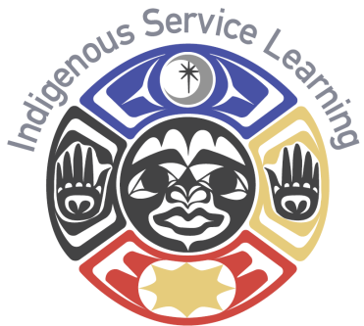
Using the Backward design for project planning create a skeleton for your service learning project
Project Outcome: What will be your end result? What is your ultimate goal? How and who will your project impact?

Inputs: What do you need to make this project a success? (I.E. resources, finances, training) Is there anyone else involved? (I.E. volunteers, faculty, partnerships)

Timeline: Create a time line to help you stay on track and ensure you are meeting your goals.

Outputs: What are your specific responsibilities? Where do these responsibilities fit on your timeline?

Reflection: Write a reflection on your project. What did you learn? What worked and what didn’t? What challenges did you face? Who did you impact with your project?

Please give a copy of your reflection to your teacher and the Center of Indigenous Service Learning.

Be sure to keep track of your hours, from research to reflection. We want to ensure you are credited for every bit of your hard work.
Date | Task | Number of Hours

Photo/Reflection Release

Photo/Reflection Release: I give Northwest Indian College permission to use my name, reflection, photos, or digital media of me and my project for publicity, recruitment or fund raising to support college programs to promote student success. Once signed, please return to the ISL Office (Bldg #5).

________________________________ _____________
Signature Date

Thank you for supporting, setting an example, and preforming this service for your community and future generation!

Course and Quarter: __________________________________ Please return to the Center of Indigenous Service Learning at
Instructor Name: __________________________________ the end of each quarter or end of your project. Please attach
Community Partner: __________________________________ student reflections if you use this form.
Service-Learning Site:_________________________________

 |  |  | Check All That Apply
 | Students Name | # Of Service Hours | College Student | Middle/High School Student | Non-Student/ Community Member | Baby Boomer (Born Between 1946-1964)
1.
2.
3.
4.
5.
6.
7.
8.
9.
10.
Total.

Native Leadership
Way of life
Inherent Rights
Community-Minded
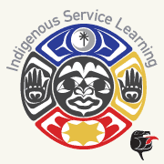

Indigenous Service Learning outcome: Cultivate and sustain the connections of people and place through community engagement and leadership.
CRITERIA | ACCOMPLISHED | DEVELOPING | BEGINNING
Academic Integration | Applies connections of service learning project to course and college outcomes. | Expresses some connection of service learning project to course and college outcomes. | Describes limited connection of service learning project to course and college outcomes
Community Needs | Determines community needs and applies tribal values of giving back through service | Demonstrates some awareness of community needs and giving back through service | Describes limited awareness of community needs and giving back through service.
Community Collaboration | Supports team engagement to advance the collective good of the community and work toward solutions. | Applies some team engagement to advance the collective good of the community and work toward solutions. | Demonstrates limited team engagement to advance the collective good of the community and work toward solutions.
Indigenous  Leadership | Applies Indigenous Leadership skills based on serving people and place from a team perspective. | Demonstrates some Indigenous Leadership skills based on serving people and place from a team perspective. | Describes limited awareness of Indigenous Leadership skills based on serving people and place from a team perspective.
Project Implementation | Creates and formulates well defined plan: Outcomes, timelines, resources and hours needed meet needs of project and community. | Project outcomes, timelines, resources and hours need more definition and are inadequate for needs of the project and community. | Project outcomes, timelines, resources and hours are not defined and/or adequate for needs of the project and community.
Reflection | Examines the impact of service project on learning, self, partners and the community: Students view themselves as empowered indigenous leaders committed to serving the community. | Demonstrates some perspectives of the impact of service project on learning  nd the community: Students want to serve the community and become an indigenous leader. | Describes limited perspectives of the impact of service project on learning, self, partners and the community: Students struggle to see the importance of serving the community.

