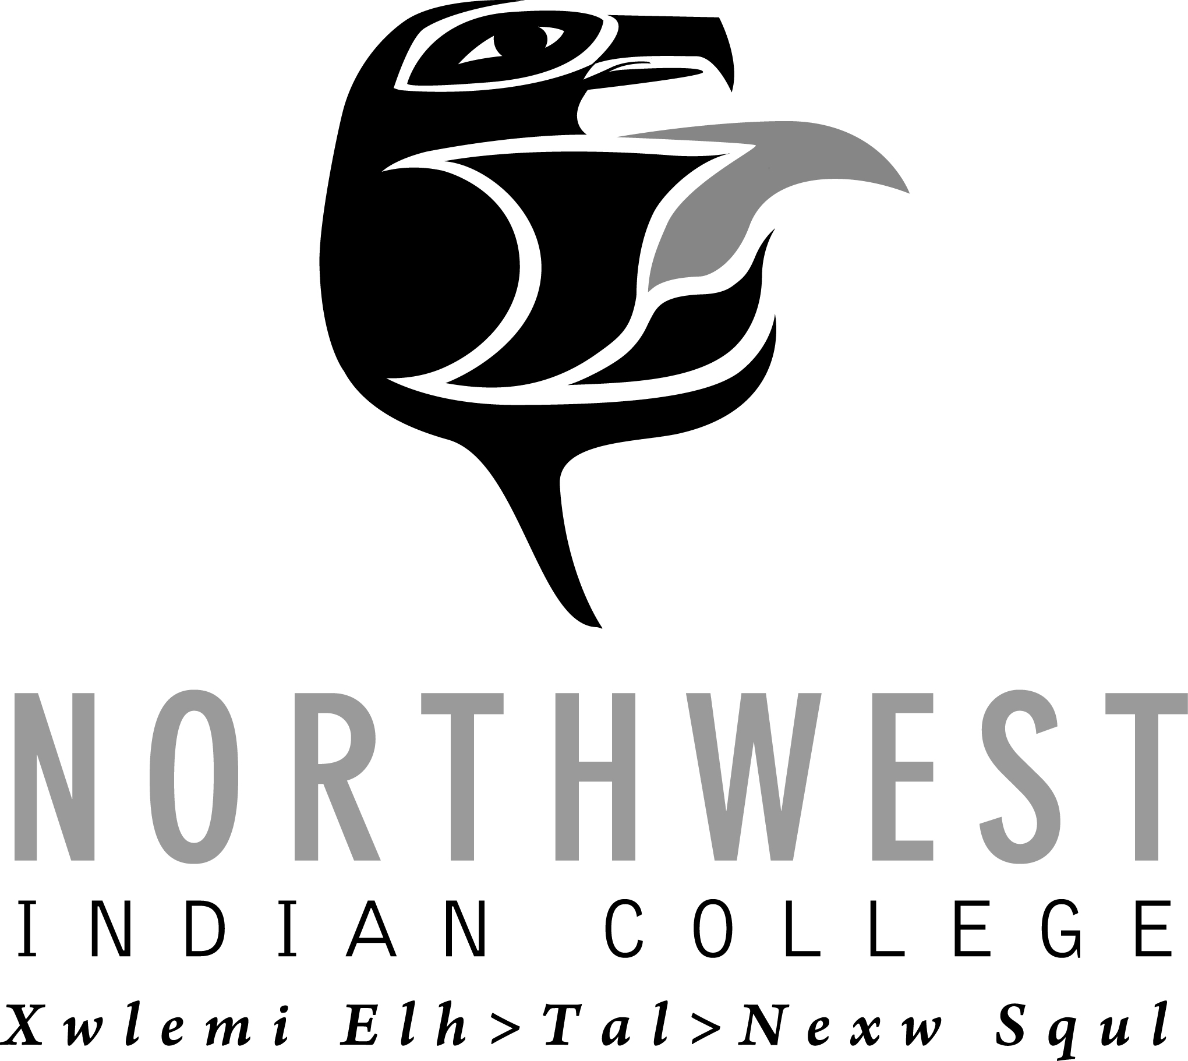
AUTHORIZATION TO PURSUE FUNDING RESOURCES
Purpose of this form is to acquire Administrative approval/authorization to begin preparation of a grant/contract proposal on behalf of Northwest Indian College. If you identify a grant/contract funding opportunity that you would like to apply for, please complete this form and return to the Office of Research and Sponsored Programs to request administrative approval.
Please submit two weeks prior to proposal due date.
DATE: Date Submitted to SP
Principle Investigator/Project Director: PI/PD Name Co-PI (if any): Co-PI/PD Name
PI Time Commitment: % of Time Co-PI Time Commitment: % of Time
Department/Program: Department &/or Program Project Will Assist
Funder/Sponsor: Agency Name
Project Title: Title & Abbreviation Funding Opportunity Number: Opp#
Award or Sub-Award: Choose an item.: If Sub-Award, Prime Awardee Agency: Agency Name
- If other, what type of award: Type of Award
Proposal Type: Choose an item Award Type: Choose an item If Research on Human Subjects, attach IRB approval.
Method of application: Choose an item If “Other” – explain: Click here to enter text
Timeline for Application Process: Due Date for submitting grant: Date Due; LOI/NOI Date: Date Due; Notification for request for full proposal date: Date Due
Proposed Project Begin Date: Begin Date Term: # Years
Purpose of Funding Opportunity: Purpose. (attach project abstract and proposed budget)
Identify any other NWIC department(s)/program(s) you are collaborating with and how: Explain
Will this project be sustainable when the grant ends: Choose an item
  - If Yes/No, explain: Explain why the project is/is not sustainable
How will project activities be continued after the grant: Choose an item
Describe how this project supports: NWIC Core Themes Explain; Strategic Plan Explain; and/or Mission Statement: Explain
Duration of Project: # of Months/Years Potential Award Amount: $Amount$
Number of Select Classification employees/positions to be paid from this grant: # ; # Select Classification; # Select Classification; # Select Classification. If Other, Explain
Indirect Cost Applicable: Choose an item. If Yes, please attach documentation on what is allowable.
  - If No, explain: Click here to enter explanation.
  - If Yes, at what rate: IDC Rate.
Amount of Matching Funds Required: $$Amount$ cash; and/or $$Amount$ In-kind.
Is grant writer requested: Choose an item.
  - If Yes, do you recommend/prefer someone: Name(s)
  - If No, name Grant Writer(s): Name(s)
A2P Completed by: Your name PI Signature:

Supervisor (Dept Chair) Approval: Date:
- Special Conditions/Notes: Notes

Dean/Vice President Approval: Date:
SEND COMPLETED FORM TO: SponsoredPrograms@nwic.edu or w/Barbara Roberts or Debbi Mele Mai in OSP.
THIS BOX IS FOR OFFICE OF RESEARCH AND SPONSORED PROGRAM USE ONLY

President’s Approval: Date:

Notify: Proposed PI Vice President ORSP Grant Writer

LOI = Letter of Intent
NOI – Notice of Intent

