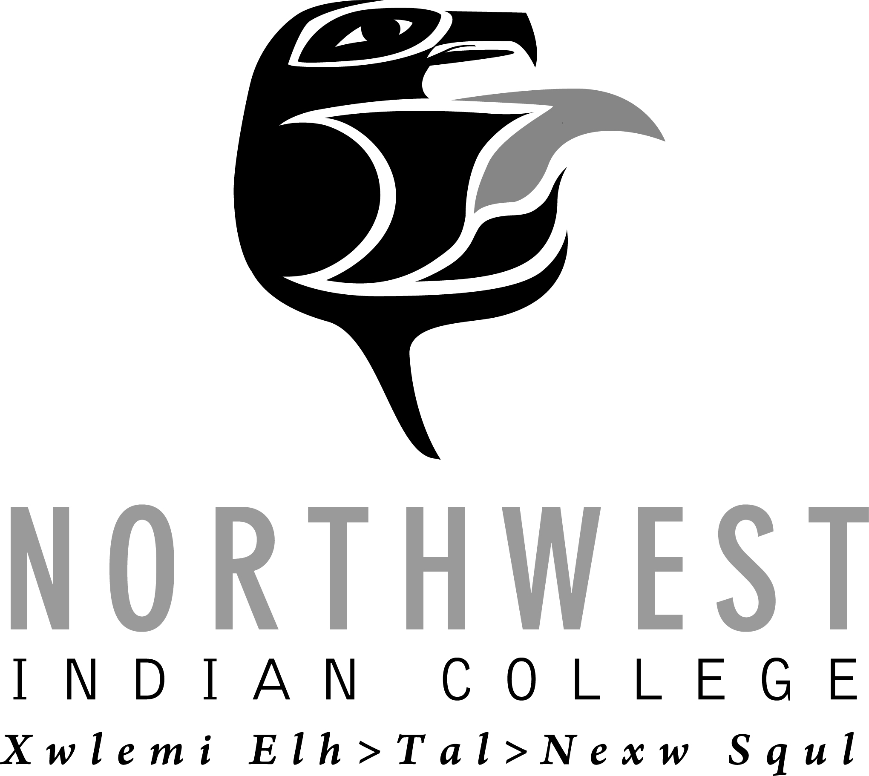
AUTHORIZATION TO PURSUE FUNDING RESOURCES
Purpose of this form is to acquire Administrative approval/authorization to begin preparation of a grant/contract proposal on behalf of Northwest Indian College. If you identify a grant/contract funding opportunity that you would like to apply for, please complete this form and return to the Office of Research and Sponsored Programs to request administrative approval. SP Enters Date
Please submit two weeks prior to proposal due date. DATE Rec’d by SP: _________

Date: Today’s Date *Principle Investigator/Project Director: PI/PD Name PI Time Commitment: % of Time
Co-PI (if any): Co-PI/PD Name Co-PI Time Commitment: % of Time
Department/Program: Department &/or Program Project Will Assist
Funder/Sponsor/Grant Agency: Agency Name Primary Agency (if Sub-award): Agency Name
Grantor Opportunity Title: Title & Abbreviation Type of Grant: Choose an item
Project Title: Title & Abbreviation Funding Opportunity Number: Opp#
Proposal Type: Choose an item Award Type: Choose an item If Other: Award Type, if Other
Award or Sub-Award: Choose an item.: If Sub-Award, Prime Awardee Agency: Agency Name
NOTE: If Research on Human Subjects, attach IRB approval.
Method of application: Choose an item If Other: Method, if Other
Timeline for Application Process: LOI/NOI Date: Date Due; Notification for request for full proposal date: Date Due; Due Date for submitting grant: Date Due
Proposed Project Begin Date: Begin Date Term: # Years
Purpose of Funding Opportunity: Purpose. (attach project abstract and proposed budget)
Identify any other NWIC department(s)/program(s) you are collaborating with and how: Explain
Will this project be sustainable when the grant ends: Choose an item
  - If Yes/No, explain: Explain why the project is/is not sustainable
How will project activities be continued after the grant: Choose an item
Describe how this project supports: NWIC Core Themes Explain; Strategic Plan Explain; and/or Mission Statement: Explain
Duration of Project: # of Months/Years Potential Award Amount: $Amount$
Number of employees/positions to be paid from this grant: # Select Classification; # Select Classification; # Select Classification; # Select Classification. If Other, Explain
Indirect Cost Applicable: Choose an item. If Yes, please attach documentation on what is allowable.
  - If No, explain: Click here to enter explanation.
  - If Yes, at what rate: IDC Rate.
Amount of Matching Funds Required: $$Amount$ cash; and/or $$Amount$ In-kind.
Is grant writer requested: Choose an item.
  - If Yes, do you recommend/prefer someone: Name(s)
  - If No, name Grant Writer(s): Name(s)
A2P Completed by: Your name PI Signature:

Supervisor (Dept Chair) Approval: Date:
- Special Conditions/Notes: Notes

Dean/Vice President Approval: Date:
SEND COMPLETED FORM TO: SponsoredPrograms@nwic.edu or w/Barbara Roberts or Debbi Mele Mai in OSP.
THIS BOX IS FOR OFFICE OF RESEARCH AND SPONSORED PROGRAM USE ONLY

President’s Approval: Date:

Notify the following: Proposed PI; Proposed Co-PI, if applicable; Dean/Supervisor/Vice President; ORSP Grant Writer.

LOI = Letter of Intent * REQUIRED IN RED
NOI = Notice of Intent

