Travel Policy
In accordance with the NWIC drug and alcohol free campus policy students will complete an Acknowledgement of Responsibility agreement. The students will agree to abstain from and not be in the presence of all drugs and alcohol while representing the college. The students will conduct themselves in the utmost respectful manner and will be held to the student conduct code (NWIC 2014-2015 Student Handbook) during travel. Any student who violates the drug and alcohol free policy or acknowledgment of responsibility will be sent home immediately while on travel. By signing the acknowledgments of responsibility, students understand that there are sanctions imposed that are a part of this policy, which the students agree to. The student in violation of this policy is responsible for the cost of any additional travel/per-diem expenses incurred as a result of the policy violation.
In addition, before travel, students will complete an Attendance & Satisfactory Progress Verification form with each of their instructors. By signing this form, the student verifies they are in good academic standing with NWIC, have no outstanding Incomplete grades, have a G.P.A. of 2.0 or better, and are currently passing all courses with a ‘C’ or better.
When leaving for a trip any student who fails to show up on time for the departure will forfeit their travel for that time period and will be responsible for any fees necessary to cancel/change travel arrangements and must return to campus or home. It is also the expectation that the student return the per-diem monies to the NWIC employee responsible for that trip.
Northwest Indian College is not responsible for any fees/costs incurred due to rescheduling of travel days/times or modes of transportation. The individual student is responsible for these expenses. Per Diem or any travel advance funds are given at a set rate and shall be used only for purchasing meals. If a student misuses these funds, additional funds will not be provided.
To be eligible for travel, a student must have at least a 2.0 cumulative GPA.
Running start students are not eligible to travel on overnight trips. Northwest Indian College will not incur any additional travel fees for running start students.

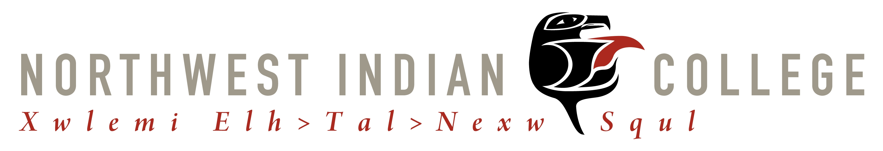
Acknowledgement of Responsibility

I, _________________________________________, acknowledge that I am representing the Northwest Indian College (NWIC) at __________________________________________________ on___________________.
- In accordance with the Drug and Alcohol Policy of NWIC, I agree to not be in the presence of and abstain from all drugs and alcohol while representing the college.

- If I fail to abstain from drugs and alcohol for the period of time described above I will be unable to participate in any college related activities where I will represent NWIC for one calendar year.

- I understand that I will be billed by NWIC to change my flight if I am on a trip where airline tickets were purchased through college funding.

- I will conduct myself in the utmost respectful manner while in attendance at this activity, knowing that I am respecting my college, my tribe, my community and myself. I will abide by what is asked of me and will be held to the student conduct code (pg. 35-37, 11-13 catalog) of NWIC during travel, participation in competitions and general conference activities, and stay with my assigned room partners as a representative of the NWIC.

________________________________________________ ___________________

Student Date

ATTENDANCE & SATISFACTORY PROGRESS VERIFICATION FOR STUDENT TRAVEL

I ______________________________________________ am planning to travel with the Northwest Indian College to_______________________________, on ____________________. I understand that in order to travel I must currently be in good fiscal standing with NWIC, have no incomplete grades, have a G.P.A. of 2.0 or better, and passing all of my courses with a C- or better.
Instructors please verify that this student is currently attending and passing your course and the student is demonstrating effort consistent with successful completion. In the event this student is not demonstrating required effort please notify the appropriate party.
Course | Attendance | All work up to date (Y/N) | Current grade | Instructor Initials

In accordance with Northwest Indian College travel policies, I understand all receipts are due immediately following return from travel. I will conduct myself in a manner appropriate for a NWIC representative and will abide by the drug and alcohol policy. Failure to comply with travel policies will result in a payback situation.

Hold Harmless
I will not hold the Northwest Indian College, its Board of Education members, its employees or agents responsible for any accidents, injuries, damages or other losses to my person or property, which may result from participation in this event/activity.

___________________________________________ __________________________

Student Date

