Using GoToTraining Inside Canvas
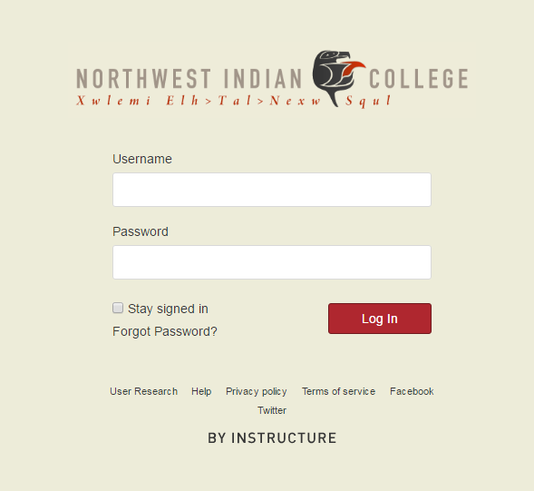
- Login to canvas using your personal username and password

- Select your course (for example, TVRS 301)
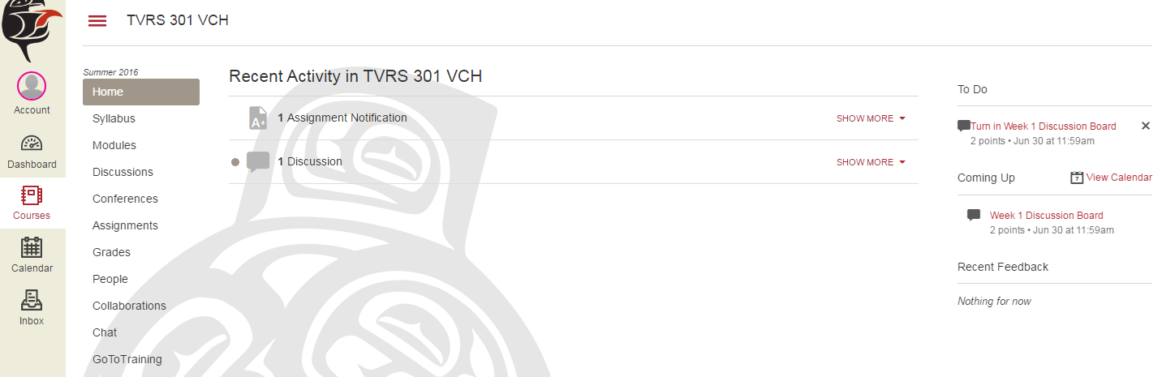
- Find ‘GoToTraining’ on the left and click on it
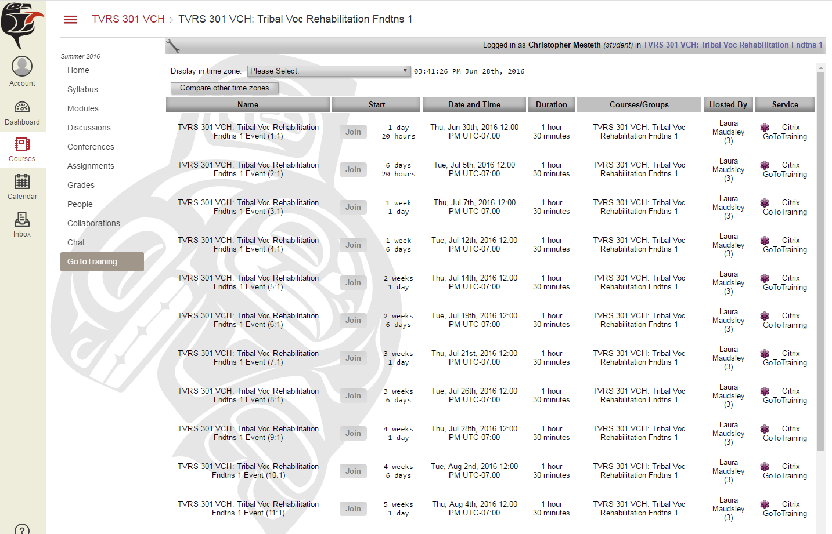
- A list will appear with all of your scheduled lecture times. When it is time to join a lecture, simply click ‘Join’. You can join up to 14 minutes before the lecture starts.
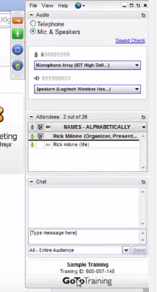
- In GoToTraining, you can type comments to your teacher and peers in this window, which will appear on the right side of your screen.
- You can also ‘raise your hand’ to get your instructor’s attention by pushing this button. Simply push this button again when you wish to ‘lower your hand’.
- After a lecture is over, you will be able to view the recording of it in canvas and re-watch it as many times as you like. Simply go to ‘Modules’, find the week you are looking for, and click on the recording. They will be titled like “Week 1 Class 1” or “Week 1 Class 2” and so on.

