Pilot TVR 301 Midway Survey Summary
- 11 of 12 students enrolled in the class completed this survey

- Students ability to follow along with the instructor during class while navigating between documents:

- Usefulness of showing documents referring to when lecturing in class:
“It would be helpful to have the instructor be more focused on the material that is presented.”

- Most students find the course materials useful, but students would benefit from more clearly labeled documents and may benefit from simpler presentation materials during class, such as PowerPoint:
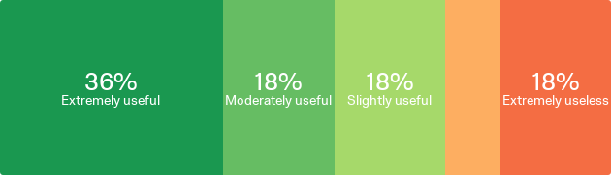
“For myself I am new so I didn't understand what certain things meant. Example assurances so maybe get more in to details of what things are. Are maybe I needed a beginners class.. I don't know lol”

- Most students are able to adapt when technology isn't working perfectly (no mic, audioconference when video not working, etc). Side note: Many students who missed class benefitted from having classes recorded so that they could watch them later and be caught up.

- Most students feel they would benefit from having a headset:

- Most students find the Canvas online learning platform easy to use. Side note: Many students benefitted from a check in about points and assignments still outstanding.

“I always depended on a text book with more details within a course. In my view, a text book to go along with the lecture could do me good”

- For most students, the demands on their time outside of class are on par with expectations (3-4 hours outside of class each week):
- Most students find the Canvas online learning platform easy to use and prefer course materials posted as the course progresses:
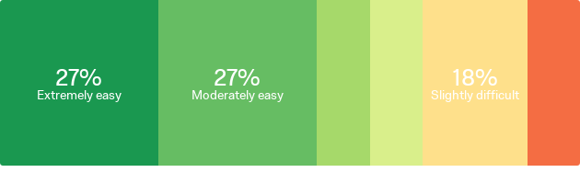

Pilot TVR 301 Student Eval of Instructor Summary
- 9 of 12 students enrolled in the class completed this survey
- Instructor scored high in all evaluation areas (content knowledge, class organization, instructor relationship, and feedback).

- How well do you feel your instructor is able to clearly communicate key concepts? 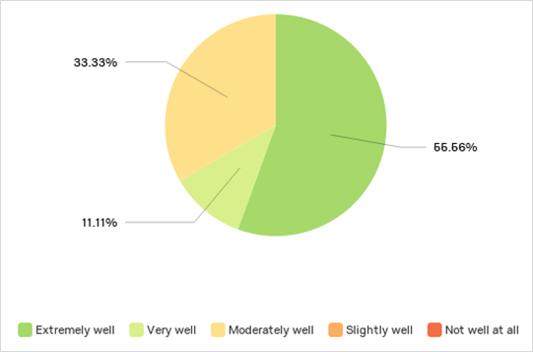
“Instructor is really into VR, knows his stuff. Good instructor.”

- How confident are you in your instructor's knowledge about Tribal VR?
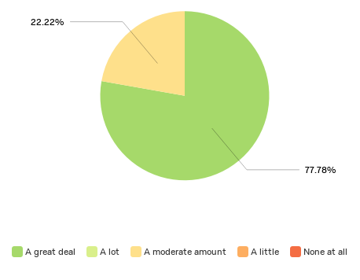

“Instructor is very knowledgeable but tends to get off track. Those new to TVR who don't know Richard might not have as much patience with him getting to his point.”

- How easy do you find it to understand course materials?
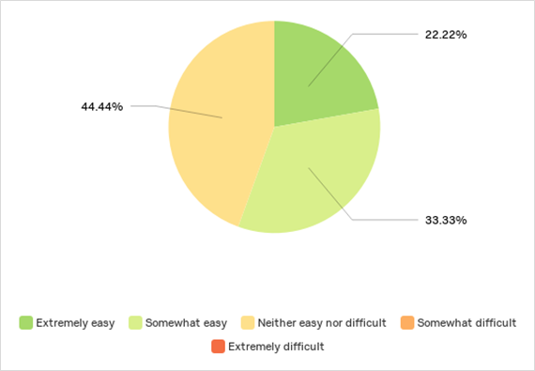
“Sometimes it seems like the teacher doesn't know what to teach and he tells stories; some stories don't really match what we're learning.”
- How respectful do you feel your instructor is to others (students, staff, professionals, etc)?
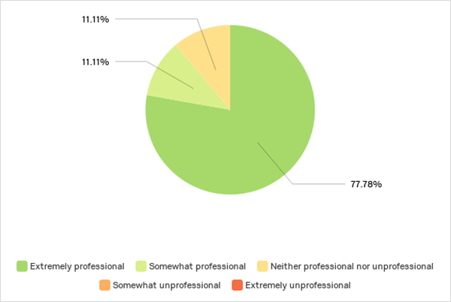
“I get confused about a lot of things talked about in class. Lengthier discussions and more clarity about key concepts would be helpful. More time for open discussion.”

- How useful is feedback provided by your instructor?
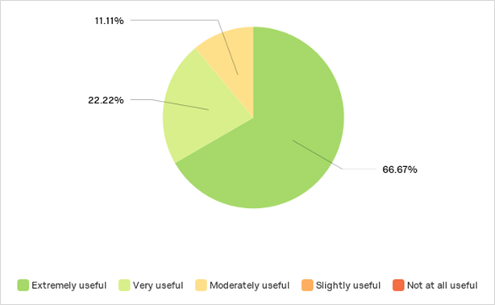
- How well are your questions answered by your instructor?

- Areas for improvement include:
  - Simplifying materials and having lengthier discussions about topics
  - Staying on topic during class / clarity about how stories relate to topic

Pilot TVR 301 Final Survey Summary
- 9 of 12 students enrolled in the class completed this survey

- Current class format (online with GotoTraining 2x/wk) is preferred to other online class arrangements and the class meeting time (12noon-1:30pm PST) worked well for most; and hour or two earlier works well too.

- Communicating during class was the biggest challenge for students (ex. relying on the chat box). This was followed by understanding the instructor’s lectures and understanding class materials.

- Specific feedback about challenges revolved a lot around making class materials easier to read (less jargon, better format, more flow):

“The challenging part of the course was to understand the documents from the Code of Federal Regulations concerning the policies and regulations with the use of its vernacular (technical gobbledygook).”

- Largest areas for improvement in Pre-Assessment that were addressed in TVR 301 were around VR history and laws & regulations. Every student who replied to final survey stated their knowledge in VR and TVR history improved

- As a class, students' knowledge improved around every course outcome

- Many who work in VR found the class very relevant to their jobs and felt that the class improved their understanding of TVR
“I plan on applying what I've learned to assist our new VR Director on the process of VR and why we do what we do.”

“I have applied and will continue to apply what I have learned in every aspect of my work. This class has given me a better understanding of what is expected of me as a VR counselor.”

“As a VR counselor, [this class was] relevant to my job. I have never known what the history of VR was until I took this class. It has opened my eyes to knowing and understanding what our true and real purpose is behind the Rehabilitation Act as well as how it was developed. It also gave me a better understanding of VR in general.”

- Improvements that would enhance students’ experience of the class include
  - Simplified materials presented during class time (ex. a PowerPoint presentation) - 67%
  - More visual material like videos or pictures – 44%
  - Better organization of class materials – 22%
“I think a short review of materials covered would help before testing [would improve my class experience].”

“The instructor, although was very knowledgeable, it was hard to follow him. No disrespect intended.”

“I think the class was good compared to any other of my online classes i have had in the past.”

“Other than better organization I can't think of anything else right now [that would improve my class experience.”

- Most students surveyed are likely to take future classes for credit:

- Most students surveyed are likely to finish the Award of Completion:

