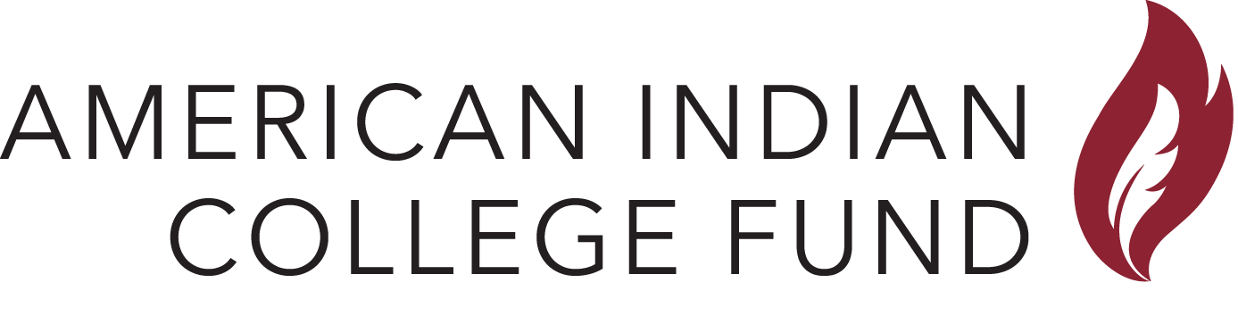NATIVE PATHWAYS TO COLLEGE
Bridge Program & High School College Choice
Application

ELIGIBILITY REQUIREMENTS
- High schools student in the 10th - 12th grades and from qualifying schools (below)
- American Indian/Alaskan Native

QUALIFYING AREA HIGH SCHOOLS
- Alaska—North Slope Barrow School District
- Washington—Ferndale, Bellingham, Squalicum, and Lummi Nation

CONTACT INFORMATION (Please completely fully)
First Name: |  |  |  | Last Name:
Tribal Affiliation: |  |  |  |  |  | Gender:  (Circle one) |  | F M
Address:
STREET CITY STATE ZIP
E-Mail:
Cell. Phone: |  |  |  |  | May we text you? |  |  |  | YES NO
Home Phone: |  |  |  |  | Date of Birth: |  | __ __ / __ __ / __ __ __ __

HIGH SCHOOL INFORMATION
High School:
Graduation Year: |  |  | GPA: |  | ACT/SAT Score:

PARENT/GUARDIAN INFORMATION
Name: |  |  | Relationship:
Primary Phone: |  |  | Email:

AGREEMENT AND SIGNATURES
By signing below, I agree to participate in the Native Pathways to College program. I recognize that the purpose of participation is to help me understand and navigate the college admissions process; and I agree to take part. I understand that involvement is voluntary and that I can disengage from the program at any time. I understand that I will NOT be compensated for participation in the Native Pathways to College program. Also, I know that all information submitted, including my photo, may be used by the American Indian College Fund for advertising, fundraising and public awareness purposes. I understand that I will not be compensated for use of these materials. I certify that all information on this application is true.

I, |  |  |  | agree to participate in the Native Pathways to College program.
 |  |  | Student Signature
I give permission for, |  |  |  |  | to participate in the Native Pathways to College program.
 |  |  | Parent/Guardian Signature
NATIVE PATHWAYS TO COLLEGE
Bridge Program & High School College Choice
Pre-Test (Page 1)

CONTACT INFORMATION
Name: |  |  | Email Address:
High School:

1. I know how to explore career choices and understand various options.

On a scale of 1 (Not Knowledgeable) – 5 (Very Knowledgeable)
Not Knowledgeable | Somewhat Knowledgeable | Undecided | Knowledgeable | Very Knowledgeable

2. I understand what college admissions officers are looking for in a strong application.

On a scale of 1 (Do Not Understand) – 5 (Fully Understand)
Do Not Understand | Somewhat Understand | Undecided | Understand | Fully Understand

3. I understand the roles that employment, volunteer experience and extra-curricular activities play in the college admissions process.

On a scale of 1 (Do Not Understand) – 5 (Fully Understand)
Do Not Understand | Somewhat Understand | Undecided | Understand | Fully Understand

4. I am confident I have the ability to succeed in college.

On a scale of 1 (Not Confident) – 5 (Very Confident)
Not Confident | Somewhat Confident | Undecided | Confident | Very Confident

5. My family is supportive of my interest in going to college.

On a scale of 1 (Not Supportive) – 5 (Very Supportive)
Not Supportive | Somewhat Supportive | Undecided | Supportive | Very Supportive

6. I am comfortable advocating for myself when it comes to finding information about going to college.

On a scale of 1 (Not Comfortable) – 5 (Very Comfortable)
Not Comfortable | Somewhat Comfortable | Undecided | Comfortable | Very Comfortable

7. I feel confident I can maintain my tribal nation’s cultural values while in college.

On a scale of 1 (Not Confident) – 5 (Very Confident)
Not Confident | Somewhat Confident | Undecided | Confident | Very Confident

8. I believe that college is affordable.

On a scale of 1 (Not Confident) – 5 (Very Confident)
Not Confident | Somewhat Confident | Undecided | Confident | Very Confident

NATIVE PATHWAYS TO COLLEGE
Bridge Program & High School College Choice
Pre-Test (Page 2)

9. I am confident I know how to finance my budget once in college.

On a scale of 1 (Not Confident) – 5 (Very Confident)
Not Confident | Somewhat Confident | Undecided | Confident | Very Confident

10. I know what FAFSA is and I am comfortable filling it out.

On a scale of 1 (Not Comfortable) – 5 (Very Comfortable)
Not Comfortable | Somewhat Comfortable | Undecided | Comfortable | Very Comfortable

11. I understand the financing process and options for going to college, such as scholarships and loans.

On a scale of 1 (Do Not Understand) – 5 (Fully Understand)
Do Not Understand | Somewhat Understand | Undecided | Understand | Fully Understand

12. I am confident I know how to search for American Indian/Alaskan Native scholarships and how to apply for them.

On a scale of 1 (Not Confident) – 5 (Very Confident)
Not Confident | Somewhat Confident | Undecided | Confident | Very Confident

13. I understand the college application process and I am comfortable completing applications.

On a scale of 1 (Do Not Understand) – 5 (Fully Understand)
Do Not Understand | Somewhat Understand | Undecided | Understand | Fully Understand

14. I understand the factors that help American Indian/Alaskan Native succeed in college.

On a scale of 1 (Do Not Understand) – 5 (Fully Understand)
Do Not Understand | Somewhat Understand | Undecided | Understand | Fully Understand

15. I understand where to find student support services on a college campus.

On a scale of 1 (Do Not Understand) – 5 (Fully Understand)
Do Not Understand | Somewhat Understand | Undecided | Understand | Fully Understand

16. I understand that there are various types of colleges/universities with different class and campus sizes.

On a scale of 1 (Do Not Understand) – 5 (Fully Understand)
Do Not Understand | Somewhat Understand | Undecided | Understand | Fully Understand

17. I am confident in my preparation for the SAT or ACT.

On a scale of 1 (Not Confident) – 5 (Very Confident)
Not Confident | Somewhat Confident | Undecided | Confident | Very Confident

