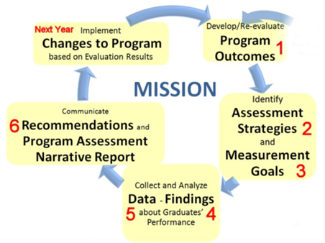
The purpose of Program Assessment is for continuous improvement Clearly defined tasks and timelines of assessment activities are outlined in the NWIC 2012-2017 Assessment Plan. The continuous improvement structure guides data gathering, analyses, interpretation of results, and decision-making
Program Assessment Matrices: The numbered columns of the program assessment matrices below relate to the same numbers in the program assessment narrative report and to the steps of the continuous improvement model.
1 Program Outcomes | 2 Assessment Strategy  (Who, what, how, when?) | 3 Measurement Goal  (expected results) | 4 Findings  (Actual results) | 5 Analysis of Data  (What students learned & what they didn’t learn) | 6 Action or Recommendation
Date | Assessment Plan Action Step | Checklist Item
Annual review | 1-Articulate outcomes |  Align program outcomes with Institutional Outcomes    Update the phase II curriculum map    Submit to aaa@nwic.edu
 | 13 - Use data to inform curricula  14 - Track Results of changes through  reports and on-going assessment  2 - Develop outcomes rubrics | ❑ Apply recommendations from 2012-13 program  assessment   Review program outcomes rubrics
Qtrly Week 2 | 3 - Identify direct and indirect assessment  opportunities at entry, midway, and exit | ❑ Identify assessment opportunities for the quarter - course, assignment/activity, and level of proficiency  (refer to phase II curriculum map)
Qtrly Week 3 | 5 – Determine or create the instructional activities or assignments that will be used to teach  6 - Determine or create the activities, assignments, or tool that will be used to assess  7 - Develop assessment strategy rubric  8 - Identify the measurement goal | ❑ Fill in assessment-ready program assessment matrix with columns 1-3 complete   Develop assessment strategy rubric for  each outcome   Email both items to aaa@nwic.edu
Qtrly | 9 - Assess students for outcome attainment  10 - Analyze the assessment data | ❑ Students assessed   Complete program assessment matrix with  columns 1-6 filled in
Qtrly course  Annual Program | 12 - Report analysis results and recommendations | ❑ Report quarterly program assessment results by submitting complete program assessment matrix at the end of each quarter - Email to aaa@nwic.edu   Submit Annual Program Assessment Report at the end of Spring quarter - Email to aaa@nwic.edu

