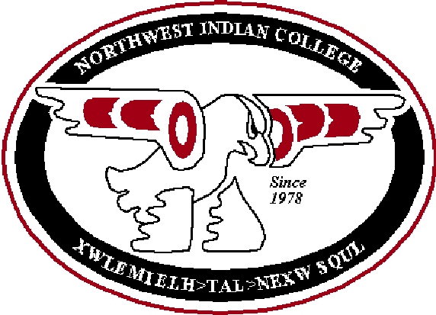
Survey of Methods
Winter Quarter 2003
Documentation

Overview of the Survey

This survey asked instructors questions about the following areas with regard to each of their courses:
- Teaching methods
- Assessment methods
- Native American content
- Writing content
- Technology content

Population Surveyed
- Courses offered in Winter 2003 quarter only at Northwest Indian College (i.e., courses that were not canceled)
- All instructors (part-time and full-time) of 100 level plus courses [including sites and learning contracts (LC)]
- 175 courses total were offered Winter 2003 quarter:
- 79 courses at Lummi Campus (45% of total # of courses offered)
- 36 courses at Extension Sites (21% of total # of courses offered)
- 59 Learning Contracts (34% of total # of courses offered)
- 1 On line courses (0.6% of total # of courses offered)
- The number of credits per course was recorded, but was not taken into account in the analysis

Method
- The survey was created by Anne Marie Karlberg and the Assessment Committee (Shelley Macy, Susan Given-Seymour, Tiffany Roosa, Misty Fuller)
- Anne Marie created a database in Access called “C:\amk\Assessment Committee\Survey of Methods (of Faculty Teaching and Assessment Methods)\Survey of Methods--with data.mdb
- Data from the surveys was entered into the database by Dan Woods in May/June 2003
- Anne Marie analyzed the surveys

Distribution
- Lummi Campus: One survey for each course that fit the criteria was put in the instructor’s mailbox
- Extension Sites: Susan Given-Seymour (Extension Services), Misty Fuller and Angel helped to mail the survey to instructors at sites
- All surveys were returned to Anne Marie Karlberg

Response Rate
- 118/179 courses (66% overall response rate)
- Lummi Campus: 77% response rate (64/83)
- Extension sites: 44% response rate (16/36)
- Learning Contracts: 64% response rate (38/59)
- On Line: 0% response rate (0/1)
- High response rate from Lummi Campus instructors
- Low response from courses with no instructor listed (2/13=15%)
- Of those who responded, 80 were not learning contract courses and 38 were learning contract courses
 | # of Total Courses Offered | # of Responses | Response Rate (%)
Lummi Campus | 83 | 64 | 77%
Sites | 36 | 16 | 44%
Learning Contracts | 59 | 38 | 64%
On-Line | 1 | 0 | 0%
Total | 179 | 118 | 66%

Analysis
- Was performed by Anne Marie Karlberg in Excel and Access in June 2003

Main Documents Used (see CD in pocket of binder)
- C:\amk\Assessment Committee\Survey of Methods (of Faculty Teaching and Assessment Methods)\Survey of Methods.xls
- C:\amk\Assessment Committee\Survey of Methods (of Faculty Teaching and Assessment Methods)\Survey of Methods--with data.mdb
- C:\amk\Assessment Committee\Survey of Methods (of Faculty Teaching and Assessment Methods)\Documentation for Survey of Methods.doc

Summary of Findings

1. Teaching Methods in Courses at NWIC

A. Non-Learning Contract Courses

Teaching Method | % of Course Time
Lecture | 20%
Seminar/Discussion | 13%
Textbook (i.e, in-class) | 12%
Independent Projects | 9%
Tutoring / One-on-One | 9%
Experiential Learning / Field Studies | 8%
Lab | 7%
Group Projects / Cooperative Learning | 6%
Demonstrations | 5%
Computer / Internet /Email | 4%
Shop / Studio | 4%
Other Teaching Methods (i.e., journal writing) | 2%
Role Plays | 1%
Videos | 0.5%

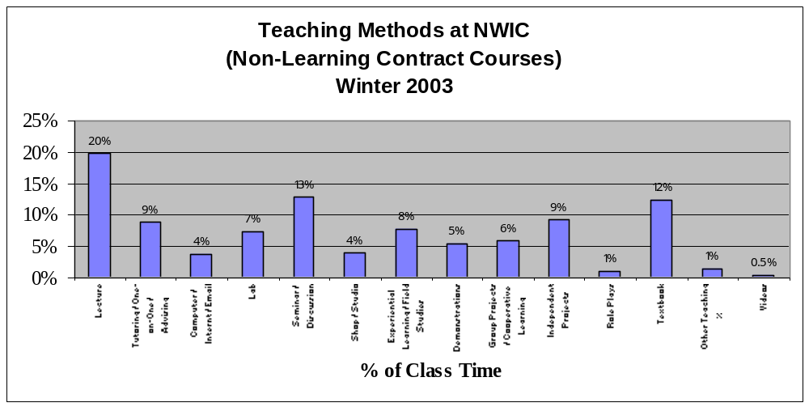

B. Learning Contract Courses

Teaching Method | % of Course Time
Textbook | 53%
Independent Projects | 10%
Tutoring / One-on-One | 9%
Other Teaching Methods (i.e., journals, self-reflection) | 9%
Experiential Learning / Field Studies | 8%
Computer / Internet /Email | 7%
Lab | 1%
Demonstrations | 1%
Role Plays | 1%
Videos | 0.3%
Group Projects / Cooperative Learning | 0.3%
Seminar Discussion | 0.3%

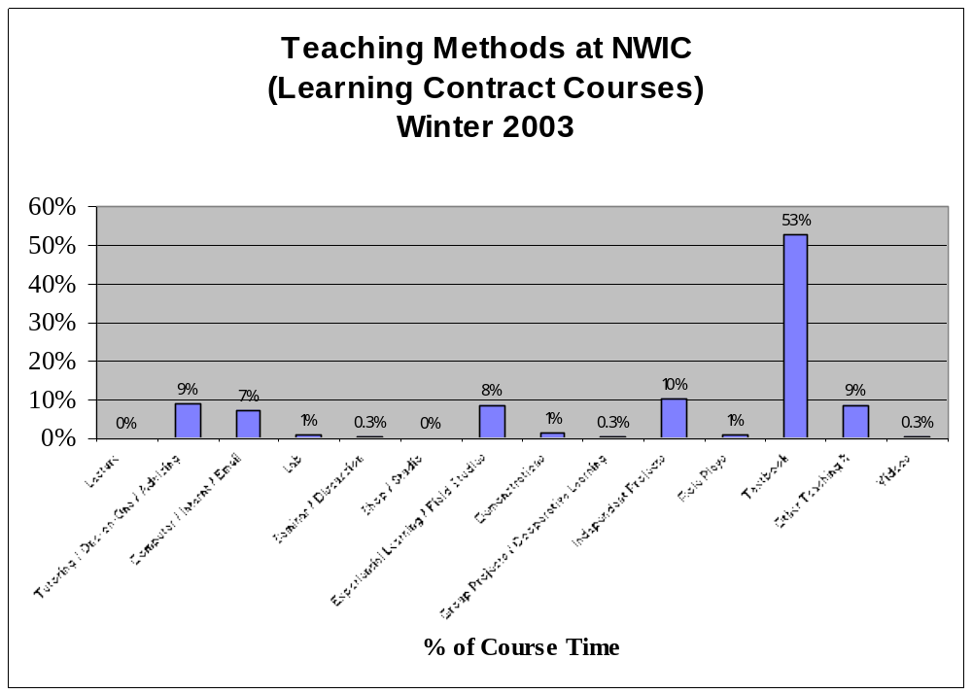

C. Non-LC and LC Courses

Teaching Method | % of Course Time
Textbook | 25%
Lecture | 13%
Independent Projects | 10%
Tutoring / One-on-One | 9%
Seminar/Discussion | 9%
Experiential Learning / Field Studies | 8%
Lab | 5%
Computer / Internet /Email | 5%
Group Projects / Cooperative Learning | 4%
Demonstrations | 4%
Other Teaching Methods (i.e., journals, self-reflection) | 4%
Shop / Studio | 3%
Role Plays | 1%
Videos | 0.5%

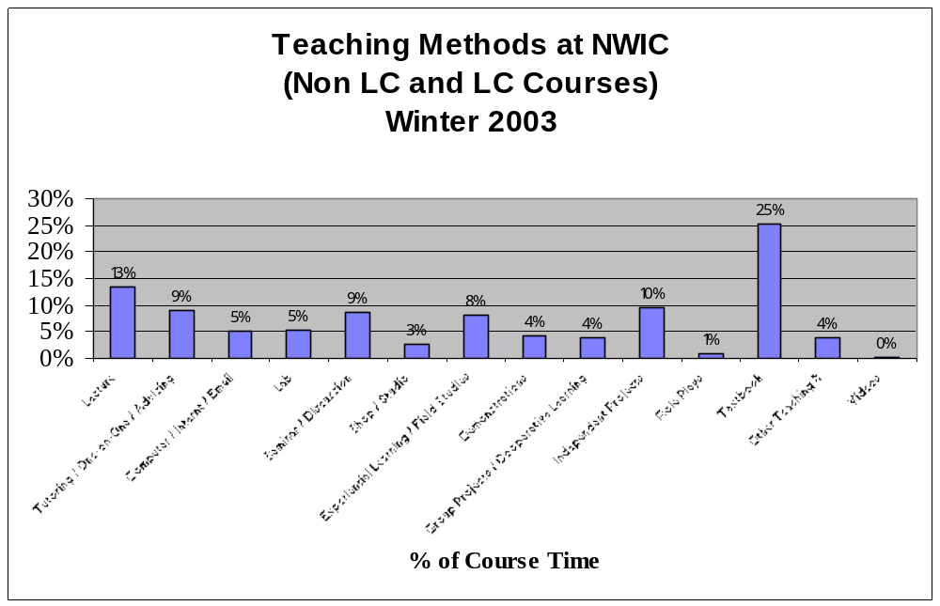

2. Assessment Methods in Courses at NWIC

A. Non-Learning Contract Courses

Assessment Method | % of Grade
Attendance / Participation | 21%
Other Written Assignments | 15%
Projects | 12%
Problem-Solving (Test/Exam/Quiz/Homework) | 8%
Short Answer (Test/Exam/Quiz/Homework) | 8%
Multiple Choice (Test/Exam/Quiz/Homework) | 7%
Demonstration | 7%
Portfolios | 6%
Fill-in-the-Blank (Test/Exam/Quiz/Homework) | 4%
Presentations | 3%
Other Assessment* | 3%
Observation | 2%
Essay (Test/Exam/Quiz/Homework) | 2%
Self-Evaluation | 2%

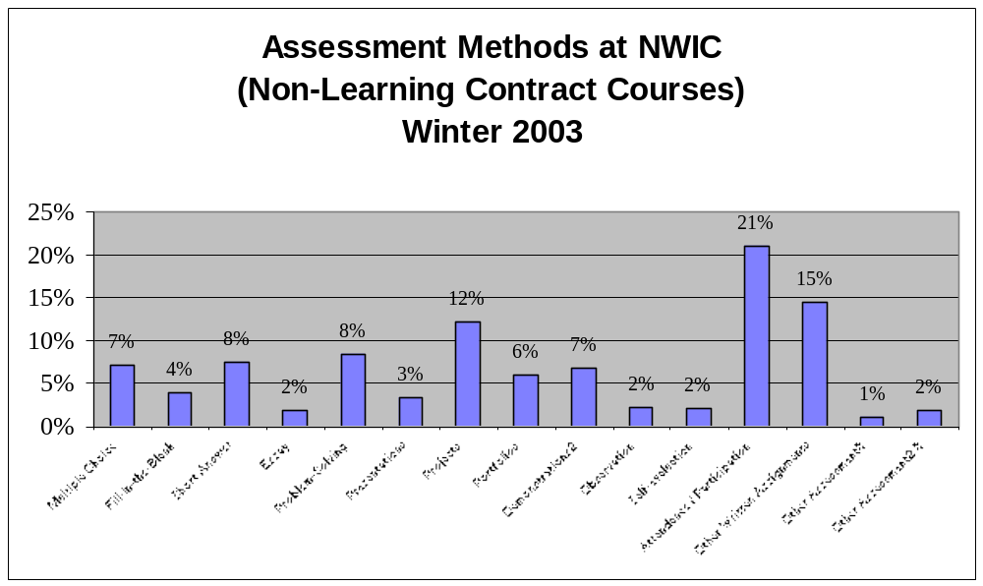

B. Learning Contract Courses

Assessment Method | % of Grade
Other Written Assignments | 39%
Projects | 13%
Essay (Test/Exam/Quiz/Homework) | 9%
Short Answer (Test/Exam/Quiz/Homework) | 8%
Multiple Choice (Test/Exam/Quiz/Homework) | 8%
Portfolios | 7%
Other Assessment* | 5%
Problem-Solving (Test/Exam/Quiz/Homework) | 4%
Self-Evaluation | 2%
Observation | 2%
Demonstration | 1%
Fill-in-the-Blank (Test/Exam/Quiz/Homework) | 1%
Attendance / Participation | 1%

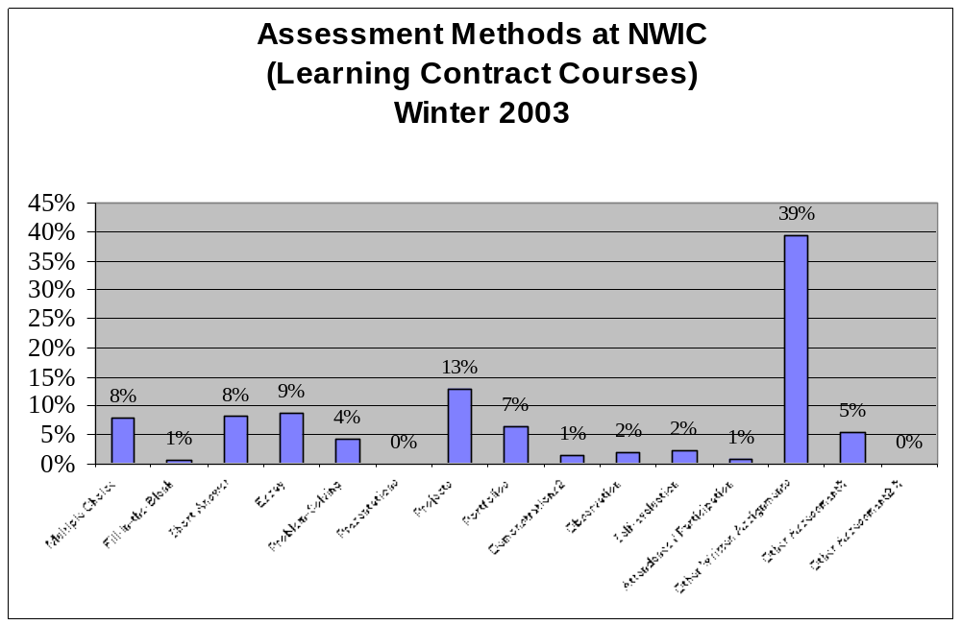

C. Learning and Non-Learning Contract Courses

Assessment Method | % of Grade
Other Written Assignments | 22%
Attendance / Participation | 14%
Projects | 13%
Short Answer (Test/Exam/Quiz/Homework) | 8%
Problem-Solving (Test/Exam/Quiz/Homework) | 7%
Multiple Choice (Test/Exam/Quiz/Homework) | 7%
Portfolios | 6%
Demonstration | 5%
Essay (Test/Exam/Quiz/Homework) | 4%
Other Assessment* | 4%
Fill-in-the-Blank (Test/Exam/Quiz/Homework) | 3%
Observation | 2%
Presentations | 2%
Self-Evaluation | 2%
- “Other Assessment” includes: memorization, advisor meetings, elder interview, encouraging others to participate, research, safety, workbook

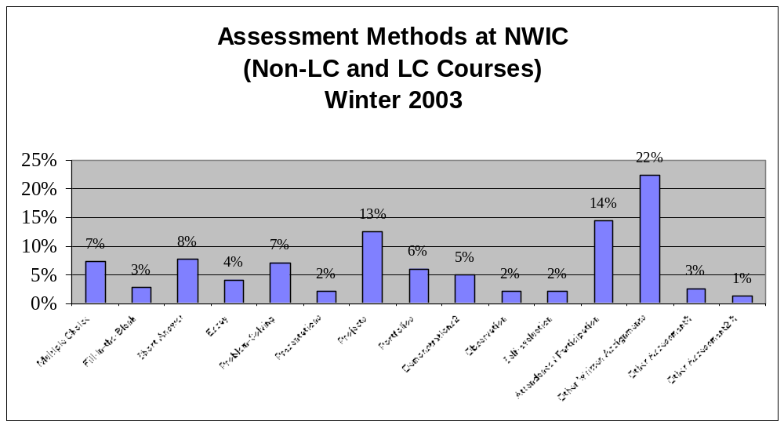

3 (i) Are courses at NWIC culturally enriched with Native American materials?

- 60% of courses at NWIC report being culturally enriched with either “some Native American material” or “primarily Native American material”.
- 5% of learning contract courses report being enriched with “primarily Native American material”, whereas 20% of non-LC courses report that level of cultural enrichment.

 | % Culturally Enriched
Level of Cultural Enrichment | Non-LC Courses | LC Courses | Overall
No Response | 5% | 8% | 6%
Minimal / No NA Material | 30% | 42% | 34%
Some NA Material | 45% | 45% | 45%
Primarily NA Material | 20% | 5% | 15%
Totals | 100% | 100% | 100%

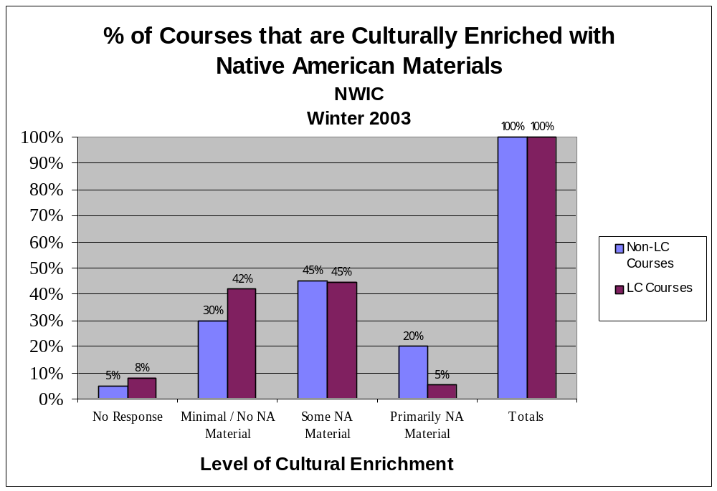

3 (ii) How are courses customized to meet the needs of Native American Students at NWIC?
- 16/118 courses report including Native American speakers
- 56/118 courses report meeting the needs of students in the following other ways:
  - NA text
  - “My style”
  - Use NA perspective
  - NA films
  - NA-specific assignments
  - Adjusted content
  - NA writers
  - NA web sites
  - NA music
  - Address different learning styles
  - Work in NA work place
  - NA art
  - Self-paced course
  - Personal reflections

4. Does the NWIC Catalog designate this course as a writing enriched course?

- 29% of respondents (34/118) did not know whether or not their course was writing enriched (and of those 34 courses, 2 of them are actually designated as writing enriched in the catalog)
- 9 instructors thought their course was designated as writing enriched (and of those 9 courses, only 1 of them is actually designated as writing enriched in the catalog)
- Of the 75 instructors who thought their course was not writing enriched, 1 of these courses is actually designated as writing enriched in the catalog

Actual # of Courses | Writing Enriched (according to instructor)
Writing Enriched (according to the catalog) | No Response | No | Yes | Total
No | 32 | 74 | 8 | 114
Yes | 2 | 1 | 1 | 4
Totals | 34 | 75 | 9 | 118
% of Courses | Writing Enriched (according to instructor)
Writing Enriched (according to the catalog) | No Response | No | Yes | Total
No | 27% | 63% | 7% | 97%
Yes | 2% | 1% | 1% | 3%
Totals | 29% | 64% | 8% | 100%

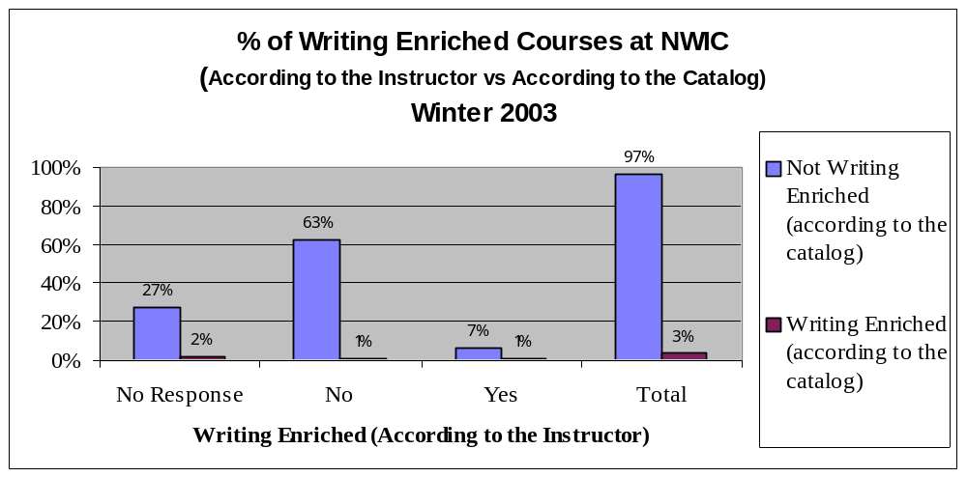

5. How is technology incorporated into courses at NWIC?

Learning Contracts:
- 55% of courses incorporate Word
- 39% of courses incorporate the Internet
- 61% of courses incorporate Email

Non-Learning Contracts:
- 46% of courses incorporate Word
- 49% of courses incorporate the Internet
- 36% of courses incorporate Email
- 24% of courses incorporate other technologies (Excel, typing, computerized accounting, La Taupe Interactive Computer Learning System, Photo Shop, tool technology, LangMaster Records, graphic arts, PowerPoint)

Actual # of Courses
 | Learning Contract Courses | Non Learning Contract Courses | Total
Word | 21 | 37 | 58
Internet | 15 | 39 | 54
Email | 23 | 29 | 52
Other | 0 | 19 | 19
Not Applicable | 12 | 20 | 32
Total # of Courses | 38 | 80 | 118
% of Courses Incorporating Each of the Following
 | Learning Contract Courses | Non Learning Contract Courses | LC and Non-LC Courses
MS Word | 55% | 46% | 49%
Internet | 39% | 49% | 46%
Email | 61% | 36% | 44%
Other | 0% | 24% | 16%
Not Applicable | 32% | 25% | 27%



