
Northwest Indian College
Student Opinion Survey (2003)

National Standardized Survey Responses

The ACT Student Opinion Survey was conducted in the spring quarter of 2003. Students were asked to complete it on their own time. To show appreciation, respondents’ names were entered in a raffle.

Responses of NWIC students are compared to national averages and percentages, when available. National averages and percentages are based on 97,696 student records from 132 2-year colleges that administered the ACT Student Opinion Survey (2-Year College form) between January 1, 2000 and December 31, 2002.

* indicates a difference between NWIC and the national norm statistically significant at the 0.05 level for either a t-test or chi square test (i.e., a significant difference)
** indicates a difference statistically significant at the 0.01 level (i.e., a more significant difference)
*** indicates a difference statistically significant at the 0.001 level (i.e., a very significant difference)

I. BACKGROUND INFORMATION

- 76 NWIC students responded to the survey in spring 2003. There were 692 students (FTE) attending NWIC spring quarter 2003.
- Age of respondents***
 | % NWIC | % National
<23 years | 15 | 56
23-29 | 34 | 19
30-39 years | 26 | 14
40-61 | 25 | 11
>=62 | 0 | 0
- Ethnicity of respondents***
 | % NWIC | % National
Native American | 88 | 2
Caucasian | 10 | 70
Hispanic | 1 | 6
Asian | 1 | 3
African American | 0 | 13
Other/no response | 0 | 6
- Gender of respondents*
 | % NWIC | % National
Male | 26 | 39
Female | 74 | 61
- Marital status: 41% of the alumni were married (the national norm is 23%).

- Purpose of attending NWIC
 | % NWIC | % National
To take courses necessary for transferring to a 4-year college or university | 30 | NA
To obtain an associate degree | 30 | NA
To obtain or maintain a certification | 9 | NA
To take a few job-related courses | 8 | NA
To take courses necessary for transferring to another 2-year college | 7 | NA
To take a few courses for self-improvement | 5 | NA
No definite purpose in mind | 4 | NA
To complete a vocational/technical program | 4 | NA
Other | 3 | NA
- Overall grade point average
 | % NWIC | % National
A- to A (3.5 – 4) | 32 | NA
B to A- (3.0 – 3.49) | 25 | NA
B- to B (2.5 – 2.99) | 17 | NA
C to B- (2.0 – 2.49) | 11 | NA
C- to C (1.5 – 1.99) | 4 | NA
D to C- (1.0 – 1.49) | 0 | NA
Below D (0 – 0.99) | 0 | NA
Have not established a GPA | 11 | NA

- Number of dependent children
 | % NWIC | % National
None | 37 | NA
1 | 13 | NA
2 | 22 | NA
3 | 16 | NA
4 or more | 12 | NA
- Number of hours per week currently employed
 | % NWIC | % National
0 or only occasional job | 27 | 25
1 to 10 | 3 | 6
11 to 20 | 9 | 17
21 to 30 | 9 | 18
31 to 40 | 46 | 22
Over 40 | 5 | 12
- Enrolment status: 71% of NWIC students were enrolled as full-time students at the time they completed this survey (the national norm is 70%).
- Number of years attended NWIC
 | % NWIC | % National
1 year | 67 | NA
2 years | 21 | NA
3 years | 8 | NA
4 or more years | 4 | NA
- Type of classes most frequently attended
 | % NWIC | % National
Day classes (morning or afternoon) | 64 | NA
Evening classes | 29 | NA
Weekend classes | 3 | NA
Other | 4 | NA
- Distance student lives from NWIC
 | % NWIC | % National
Less than 1 mile | 8 | NA
1 to 5 miles | 26 | NA
6 to 10 miles | 22 | NA
11 to 20 miles | 19 | NA
21 to 40 miles | 12 | NA
Over 40 miles | 12 | NA

- Educational and/or employment status: Status at time student entered NWIC
 | % NWIC | % National
Entered after working for a period of time (excluding summer work) | 52 | 30
Transferred from another 2-year college | 4 | 4
Entered after completing military service | 3 | 2
Entered directly from high school | 3 | 38
Transferred from a 4-year college | 1 | 8
Other | 37 | 17

- Financial aid: 81% of students indicate they receive any type of federal, state, or college-sponsored student financial aid.
- and Q. Current area of study at NWIC and occupational choice
 | Current area of study |  | Occupational choice
 | % NWIC | % National | % NWIC | % National
Undecided | 7 | 9 | 8 | NA
Agriculture | 2 | 2 | 3 | NA
Business (management/office) | 9 | 16 | 9 | NA
Communications | 0 | 2 | 0 | NA
Community and personal services | 0 | 4 | 5 | NA
Computer and Information Science | 2 | 7 | 3 | NA
Cross-disciplinary studies | 3 | 2 | 0 | NA
Education / Teacher Education | 49 | 10 | 44 | NA
Engineering / Engineering-related tech | 0 | 5 | 2 | NA
Health Sciences and Allied Health | 4 | 20 | 6 | NA
Home Economics | 6 | 1 | 3 | NA
Mathematics | 0 | 0.3 | 0 | NA
Sciences (bio and physical) | 4 | 2 | 2 | NA
Social sciences | 9 | 4 | 8 | NA
Trade and industrial | 3 | 4 | 5 | NA
Visual and performing arts | 3 | 8 | 3 | NA

II. COLLEGE IMPRESSIONS

- Primary reason for attending NWIC (3 = major reason, 2 = minor reason, 1 = not a reason)
 | NWIC Avg. | National Avg.
Convenient location | 2.51 | NA
Good chance of personal success | 2.44 | NA
Offered courses wanted | 2.32 | NA
Could work while attending | 2.31 | NA
Availability of scholarship / financial aid | 2.30 | NA
Liked the social atmosphere | 2.10 | NA
Liked the size of the college | 2.10 | NA
Low cost of attending | 2.03 | NA
Good vocational or academic reputation | 1.82 | NA
Advice of parents or relatives | 1.31 | NA
Wanted to be with friends | 1.22 | NA
Advice of high school counselor, teacher, principal | 1.10 | NA

- Respondent’s rating of NWIC at time of admission
It was their… | % NWIC | % National
1st choice (4) | 77 | NA
2nd choice (3) | 19 | NA
3rd choice (2) | 4 | NA
4th choice or lower (1) | 0 | NA
Group average | 3.73 | NA
- If student could start college over, would they choose to attend NWIC again?
 | % NWIC | % National
Definitely yes (5) | 49 | NA
Probably yes (4) | 31 | NA
Uncertain (3) | 12 | NA
Probably no (2) | 7 | NA
Definitely no (1) | 1 | NA
Group average | 4.19 | NA

- Overall impression of quality of education at NWIC
 | % NWIC | % National
Excellent (5) | 39 | NA
Good (4) | 43 | NA
Average (3) | 14 | NA
Below average (2) | 4 | NA
Very inadequate (1) | 0 | NA
Group average | 4.18 | NA

- III. COLLEGE SERVICES: USAGE AND LEVEL OF SATISFACTION
Ranked by satisfaction level (5=very satisfied, 4=satisfied, 3=neutral, 2=dissatisfied, 1=very dissatisfied). Significant differences could not be determined for satisfaction level due to the small number of students responding to that section of the question.
 | % who used the service |  | Satisfaction level
 | NWIC | National | NWIC | National | Difference
College-sponsored social activities | 20 | 16 | 4.25 | 3.99 | 0.26
Cultural programs and activities | 36*** | 10 | 4.20 | 4.07 | 0.13
College-sponsored tutorial services | 26** | 17 | 4.19 | 4.10 | 0.09
Library/learning resources center facilities & services | 47*** (*more males than females) | 66 | 4.15 | 4.18 | -0.03
Computer services | 47* | 60 | 4.12 | 4.20 | -0.08
College orientation program | 18*** | 36 | 4.09 | 3.91 | 0.18
Personal counseling services | 20* | 14 | 4.08 | 4.01 | 0.07
Academic advising / course planning services | 58 (**more females than males) | 59 | 4.02 | 3.93 | 0.09
Financial aid services | 66* | 51 | 3.98 | 4.04 | -0.06
Career planning services | 34** | 20 | 3.96 | 3.98 | -0.02
Recreational and intramural programs | 9 | 11 | 3.75 | 4.03 | -0.28
Cafeteria / food services | 26*** | 46 | 3.75 | 3.64 | 0.11
Job placement services | 9 | 8 | 3.67 | 3.74 | -0.07
Student employment services | 21*** | 10 | 3.54 | 4.01 | -0.47
Parking facilities / services | 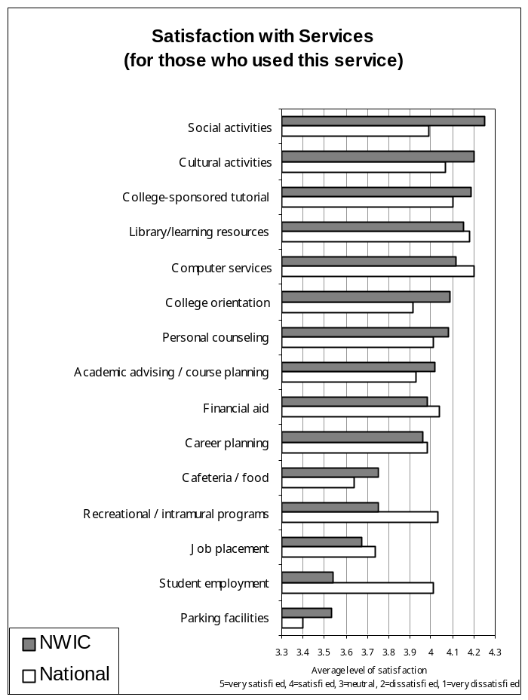 49*** | 77 | 3.53 | 3.40 | 0.13
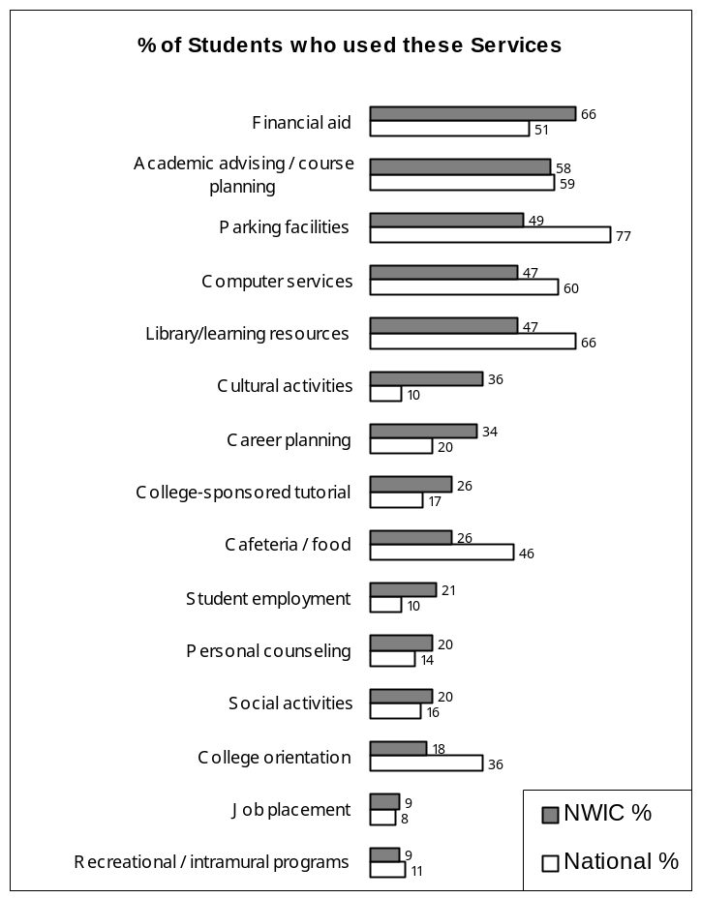

IV. COLLEGE ENVIRONMENT: SATISFACTION WITH DIFFERENT ASPECTS OF NWIC

Ranked by level of satisfaction (5=very satisfied, 4=satisfied, 3=neutral, 2=dissatisfied, 1=very dissatisfied)

Academic
 | NWIC Average | National Average | Difference
- Attitude of the teaching staff toward students | 4.51 | 4.14 | 0.38***
- Class size relative to the type of course | 4.37 | 4.22 | 0.16
- Value of the information provided by advisor | 4.19 | 3.86 | 0.33**
- Quality of instruction in major area of study | 4.17 | 4.03 | 0.15
- Out-of-class availability of instructors | 4.09 | 3.90 | 0.19
- Course content in major area of study | 4.08 | 3.97 | 0.10
- Challenge offered by program of study | 4.06 | 4.00 | 0.06
- Availability of advisor | 4.06 (* part-time more satisfied) | 3.85 | 0.21
- Flexibility to design own program of study | 4.05 (* part-time more satisfied) | 3.91 | 0.13
- Testing / grading system | 4.02 (* females more satisfied) | 3.96 | 0.06
- Preparation you are receiving for your chosen occupation | 3.91 | 3.90 | 0.01
- Variety of courses offered | 3.82 | 3.90 | -0.07

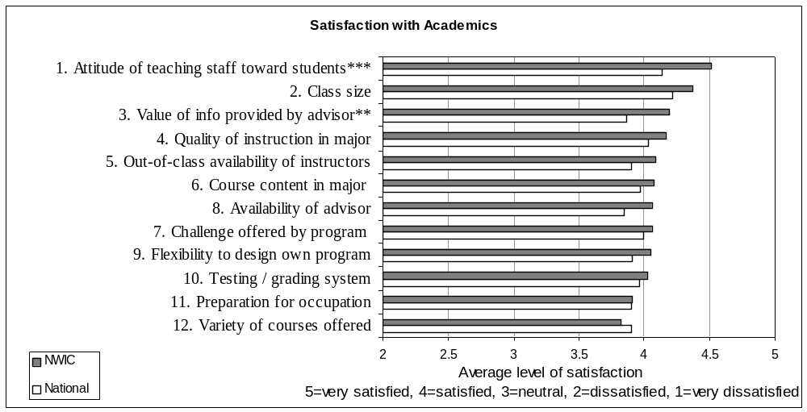

Admissions
 | NWIC Average | National Average | Difference
- Assistance provided by the NWIC staff when you entered this college | 3.89 | 3.86 | 0.03
- General admissions/entry procedures | 3.83 (* females more satisfied) | 3.87 | -0.04
- College catalog/admissions publications | 3.83 | 3.97 | -0.14
- Availability of financial aid information prior to enrolling | 3.81 (* female more satisfied) | 3.77 | 0.04
- Accuracy of college information received before enrolling | 3.57 (* part-time more satisfied) | 3.86 | -0.29*
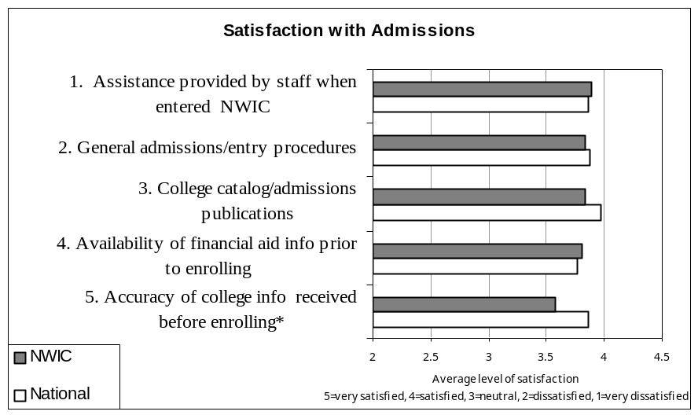
Rules and Policies
- Personal security/safety at NWIC | 3.71 (* females more satisfied) | 3.92 | -0.21
- Rules governing student conduct at NWIC | 3.59 | 3.89 | -0.30*
- Academic probation and suspension policies | 3.51 | 3.62 | -0.11
- Student voice in NWIC policies | 3.34 | 3.54 | -0.20
- Purposes for which student activity fees are used | 3.13 | 3.47 | -0.34*
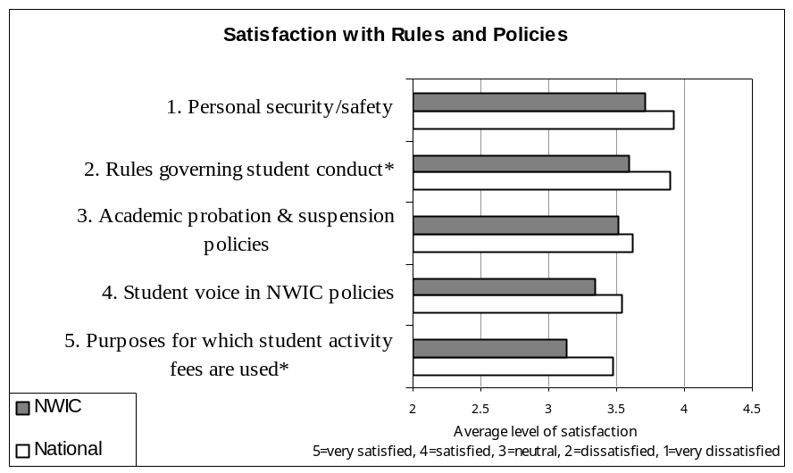

Facilities
 | NWIC Average | National Average | Difference
- Classroom facilities | 3.91 | 3.95 | -0.04
- Business-training facilities/equipment (computers, typewriters, etc) | 3.72 | 3.93 | -0.21
- Study areas | 3.65 | 3.91 | -0.26
- NWIC bookstore | 3.58 | 3.69 | -0.11
- General condition and appearance of building and grounds | 3.54 | 4.00 | -0.46**
- Laboratory facilities | 3.26 | 3.84 | -0.58***
- Student community center/student union | 3.21 | 3.73 | -0.52**
- Industrial arts/shop facilities (wood-working, mechanical, etc.) | 2.87 | 3.58 | -0.71***
- Athletic facilities | 2.52 | 3.52 | -1.00***
- Availability of adequate housing for students | 2.00 | 3.31 | -1.31***

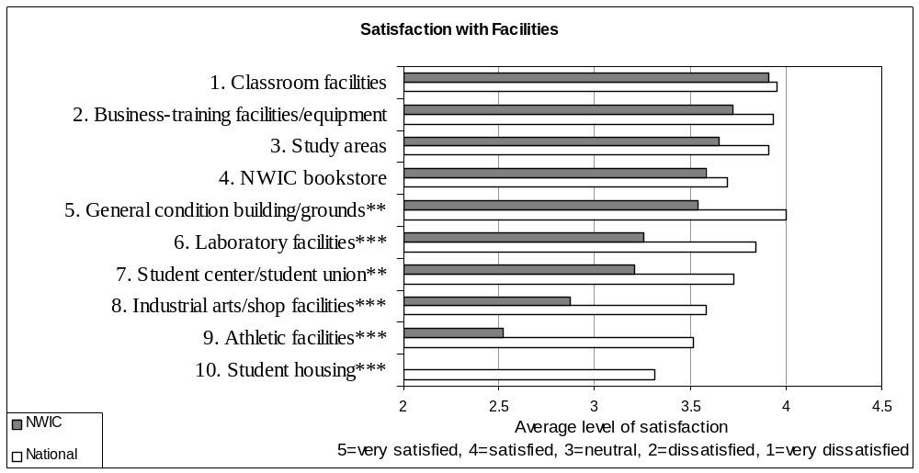

Registration
 | NWIC Average | National Average | Difference
- Academic calendar for NWIC (e.g., semester or quarter system) | 3.90 | 3.93 | -0.03
- General registration procedures | 3.80 | 3.84 | -0.04
- Billing and fee payment procedures | 3.60 | 3.82 | -0.22
- Availability of courses you want at times you can take them | 3.39 (* females & part-time students more satisfied) | 3.59 | -0.20
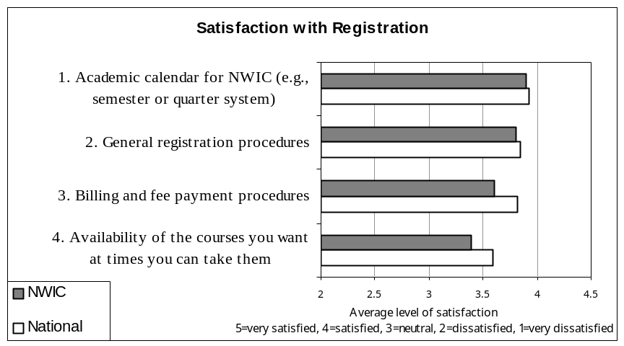
General
- NWIC in general | 4.07 (** females more satisfied) | 4.05 | 0.02
- Racial harmony at NWIC | 3.94 (** females more satisfied) | 3.92 | 0.02
- Attitude of NWIC non-teaching staff toward students | 3.83 (* part-time more satisfied) | 3.75 | 0.08
- Concern for you as an individual | 3.82 | 3.71 | 0.11
- Opportunities for personal involvement in campus activities | 3.69 | 3.68 | 0.01
- Opportunities for student employment | 3.39 | 3.58 | -0.19
- Student government | 3.25 | 3.51 | -0.26
- NWIC media (college newspaper, campus radio, etc.) | 2.65 | 3.53 | -0.88***
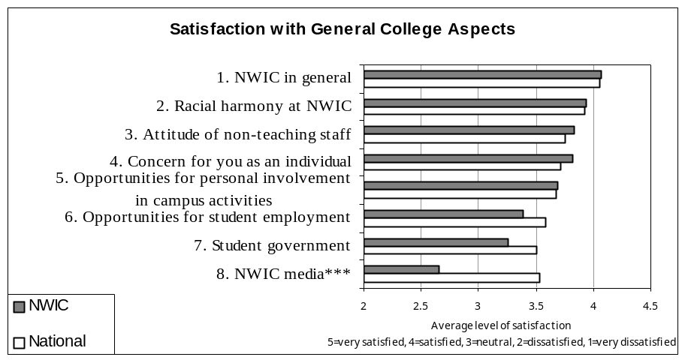

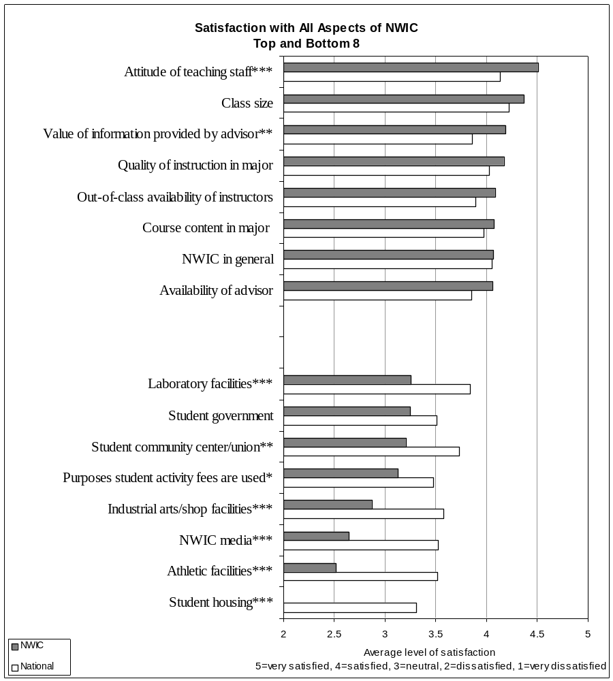

NWIC-Specific Survey Responses

This section has responses for questions that NWIC created.

Site at which respondents were taking their courses

 | NWIC Respondents
 | # | %
Lummi campus | 26 | 34
Nez Perce | 24 | 32
Muckleshoot | 7 | 9
Skokomish | 5 | 7
Port Gamble | 3 | 4
Nisqually | 2 | 3
Makah | 1 | 1
Nooksack | 1 | 1
Blank | 7 | 9
Totals | 76 | 100%

Advising

 | % Strongly disagree | % Disagree | No opinion | % Agree | % Strongly Agree | % Agree or Strongly Agree
- My advisor provides the help I need to select courses necessary to complete my degree program | 3% | 7% | 13% | 39% | 37% | 76%
- My advisor helps me cope with academic difficulties (i.e., poor grades, adding and dropping courses, etc.) | 3% | 9% | 16% | 40% | 31% | 72%

Financial Aid

 | % Strongly disagree | % Disagree | No opinion | % Agree | % Strongly Agree | % Agree or Strongly Agree
- I understand the academic requirements and standards expected of me to keep my financial aid | 11% | 6% | 13% | 40% | 29% | 69%
- I found it easy to communicate with the financial aid counselors | 8% | 15% | 23% | 35% | 18% | 53%

- In order to meet their schooling and/or basic living expenses…
12% of students report not needing to work
35% of students report needing to work part-time
53% of students needing to work full-time

Cultural

 | % Strongly disagree | % Disagree | No opinion | % Agree | % Strongly Agree | % Agree or Strongly Agree
- NWIC staff and employees are equally supportive of all racial/ethnic groups | 4% | 6% | 13% | 36% | 41% | 77%
- NWIC staff and employees create a sense of belonging for students | 6% | 4% | 14% | 42% | 33% | 75%
- At NWIC, I have been provided opportunities to learn more about myself as a Native person | 3% | 3% | 22% | 45% | 27% | 72%
- My classes/experiences at NWIC have provided me with the opportunities too learn more about my Native culture | 3% | 2% | 25% | 49% | 21% | 70%
- I now have a deeper awareness of the contributions of Native people to western society | 3% | 0% | 27% | 36% | 34% | 70%
- My experiences at NWIC have prepared me to contribute to my tribal community | 3% | 3% | 32% | 33% | 29% | 62%

College Impressions

 | % Strongly disagree | % Disagree | No opinion | % Agree | % Strongly Agree | % Agree or Strongly Agree
- NWIC has helped me meet the goals I came here to achieve | 1% | 4% | 14% | 51% | 29% | 80%
- Through my experiences at NWIC, I have developed a sense of purpose, value and meaning | 3% | 1% | 22% | 39% | 35% | 74%
- NWIC welcomes and uses feedback from students to improve the college | 6% | 4% | 21% | 51% | 18% | 69%

College Contribution

NWIC has contributed significantly to my… | % Strongly disagree | % Disagree | No opinion | % Agree | % Strongly Agree | % Agree or Strongly Agree
- Personal growth (i.e., developing self-understanding, self-discipline, and mature attitudes, values and goals) | 0% | 1% | 12% | 46% | 41% | 87%
- Intellectual growth (i.e., acquiring knowledge, skills, ideas, concepts, analytical thinking) | 1% | 1% | 12% | 46% | 39% | 86%
- Preparation for future study | 4% | 1% | 16% | 45% | 33% | 78%
- Social growth (i.e., understanding others and their views, adapting successfully to a variety of social situations) | 1% | 1% | 21% | 41% | 35% | 76%
- Preparation for a career | 3% | 10% | 12% | 39% | 36% | 75%

Outcomes

NWIC has contributed significantly to my… | % Strongly disagree | % Disagree | No opinion | % Agree | % Strongly Agree | % Agree or Strongly Agree
- Use computers (i.e., email, the Internet, Word, etc.) more effectively | 0% | 2% | 16% | 41% | 42% | 83%
- Speak more effectively | 0% | 3% | 17% | 56% | 24% | 80%
- Write more effectively | 0% | 1% | 22% | 49% | 27% | 76%
- Understand and apply math concepts and statistical reasoning | 0% | 6% | 17% | 57% | 19% | 76%
- Develop problem-solving skills | 0% | 7% | 18% | 55% | 19% | 75%
- Learn to think clearly and reason | 3% | 4% | 22% | 46% | 24% | 70%
- Read with greater speed and better comprehension | 0% | 9% | 26% | 41% | 24% | 65%
- Apply scientific knowledge and skills | 2% | 5% | 43% | 36% | 15% | 51%
- Learn principles for improving my physical and mental health | 2% | 8% | 40% | 38% | 12% | 51%
- Appreciate the fine arts, music, literature, and the humanities | 0% | 7% | 44% | 30% | 20% | 49%



