Table of Contents
(Simply ctrl+click on the section title you wish to view and it will take you to that section)

How to Access Canvas
Getting Started
Syllabus
Modules
Assignments
Discussions
Inbox
Grades
Quizzes
Videos / Lectures
Extra Help

How to Access Canvas
- You can look at canvas on your computer by going to https://nwic.instructure.com, or
- You can use your smartphone to download the Canvas app (it’s free!)
Getting Started
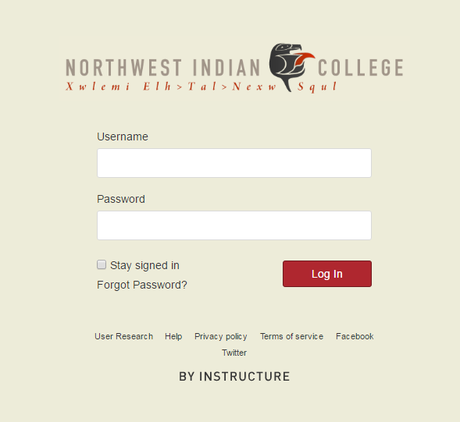
- Log in to Canvas using your email address and password you created. The login page will look like this:

- Once you log in, the homepage will appear, and display your ‘Dashboard’.
- To access your online classroom, simply click on the box with its title (for example, TVRS 301)
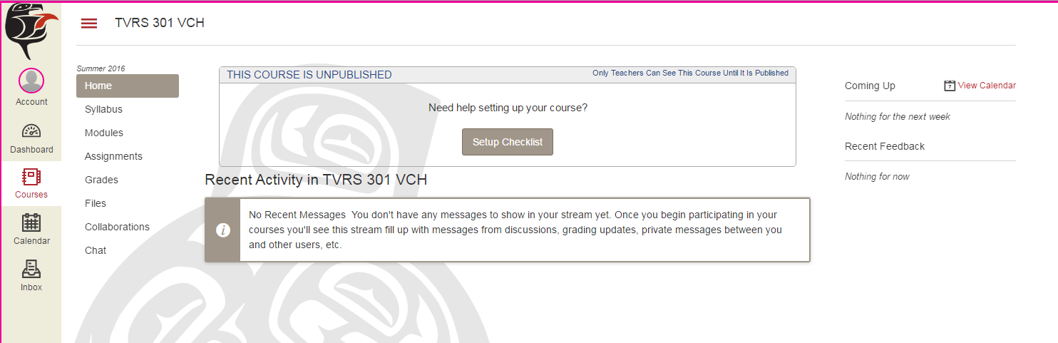
- Now you can see everything related to the class! A helpful tool is found at the right of your screen: “Coming Up” and “Recent Feedback”. “Coming Up” will alert you to assignments that need to be done soon for your class, and “Recent Feedback” will alert you to assignments that have recently been graded by your teacher. The next thing you might want to take a look at is the class syllabus, which can be found if you click this button on the left of your screen:
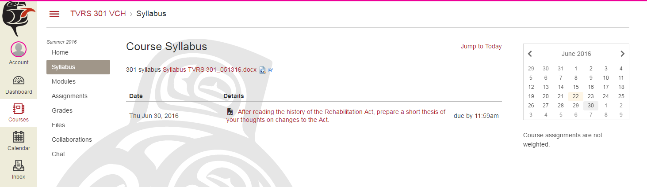
- You can download and view the syllabus file by clicking on this link:
Modules
- In your classes, your instructor may divide your lessons into sections, known as ‘modules’ in Canvas (usually 1 module per week). Modules can be accessed by clicking here:
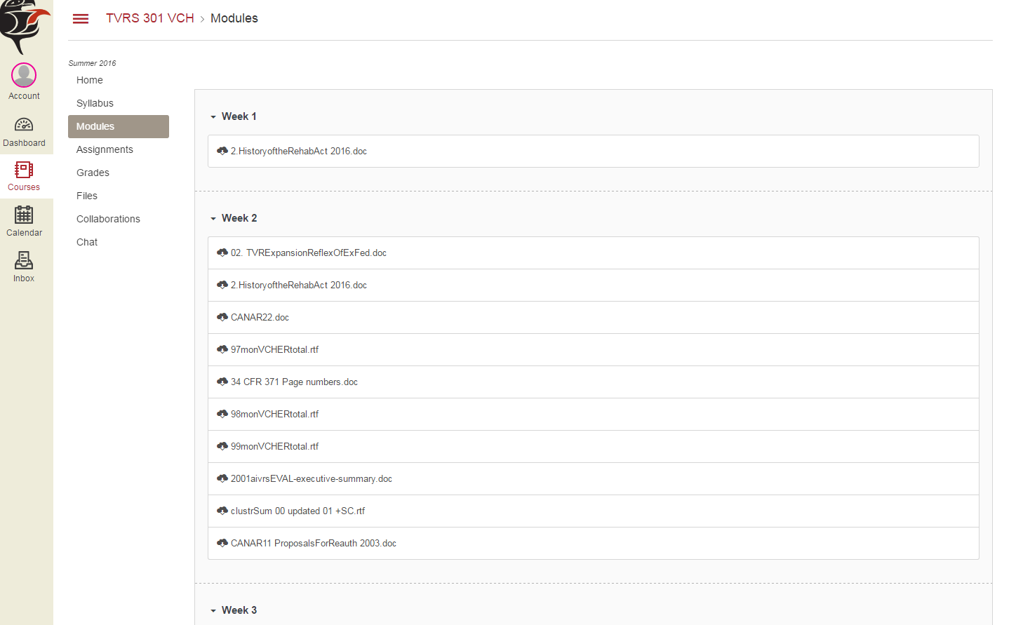
- This page will appear. Here, you can see all of the class assignments, files, quizzes, and discussions divided by week:

- ‘Modules’ is an easy way to check what you need to do each week!
Assignments
- To look at only the things you need to do for the class, like homework, you can view them all in the ‘Assignments’ tab on the left of your screen.
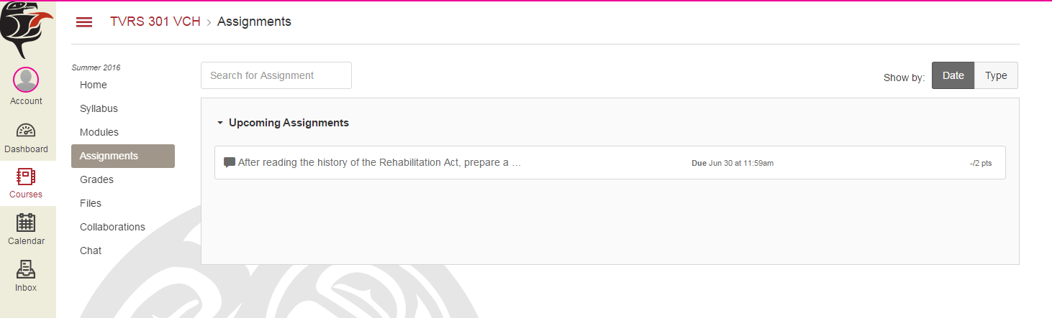
- You can view all the homework your instructor has posted on this page, as well as the due date and number of points it is worth. Right now, it looks like the first assignment is already up!

- By clicking on an assignment, it will take you to a page where you can submit your homework. This assignment listed here is actually a discussion post, which we will discuss in the next section.
Discussions
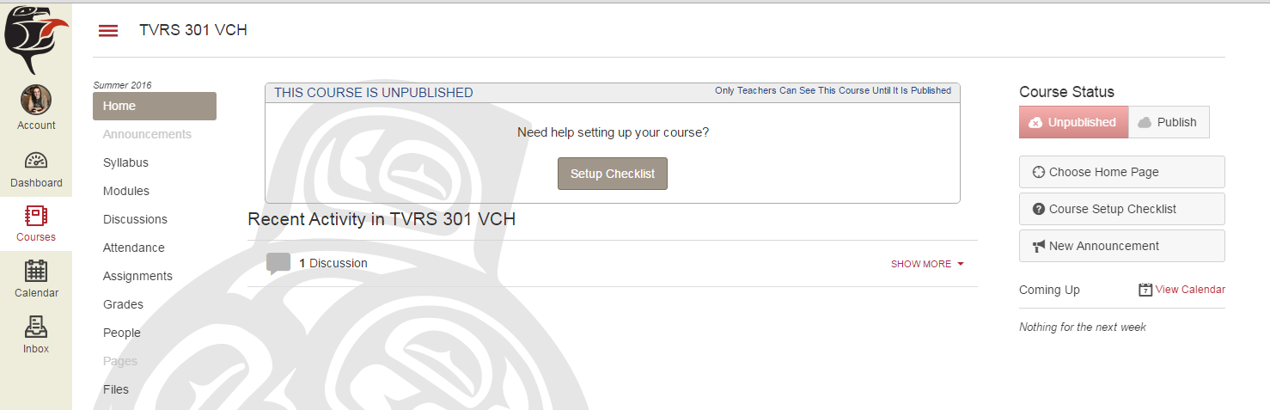
- Discussions are a very important feature in Canvas, and you will probably end up using them quite often. You can access them from assignments (as mentioned above), modules, or the ‘Discussions’ tab on the left of your screen.
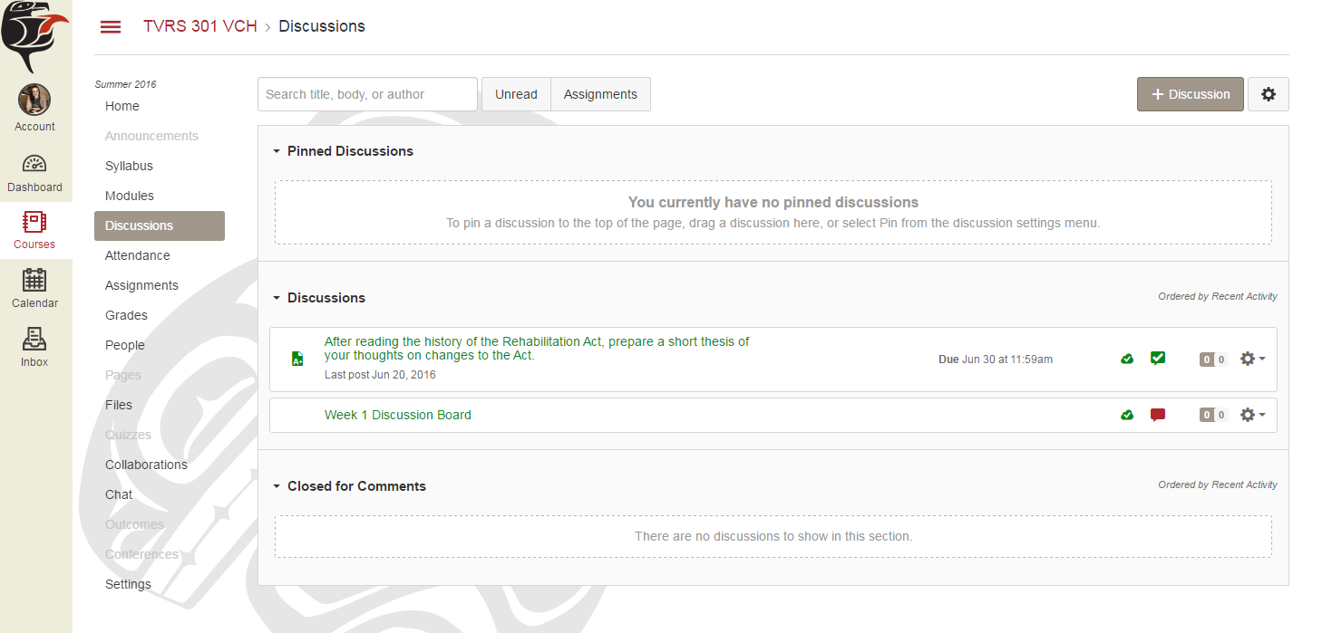
- A list of all class discussions is located here. To view or submit a discussion post, just click on the discussion you want to work with.

- Here, you can view the directions from your instructor, as well as replies from other students. You can also post your own reply, which you will often need to do as homework.
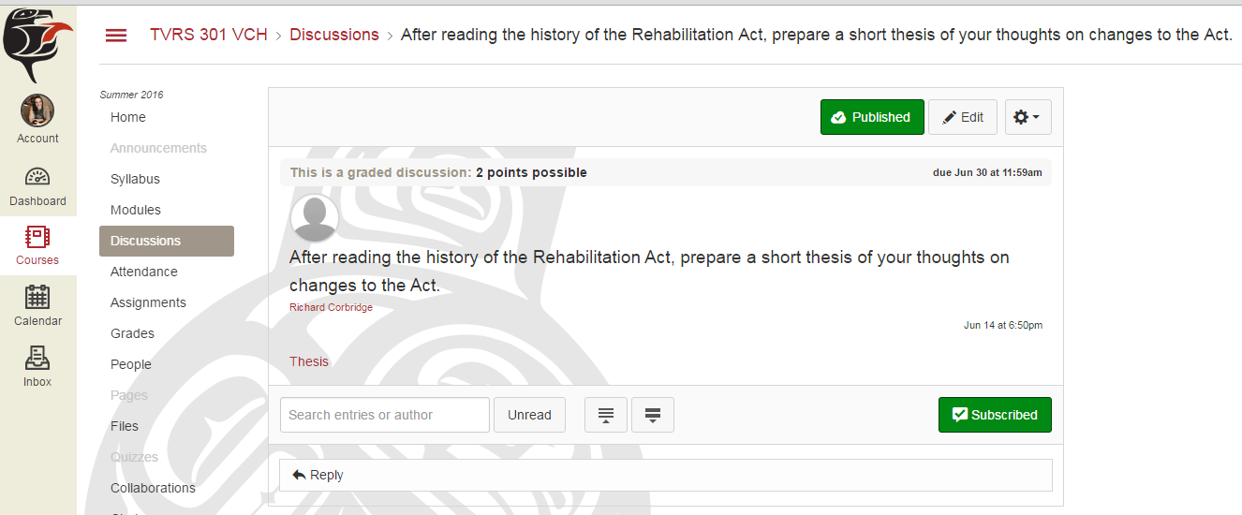
- To post your own reply (so you can get credit for it), simply push ‘Reply’ under the prompt.
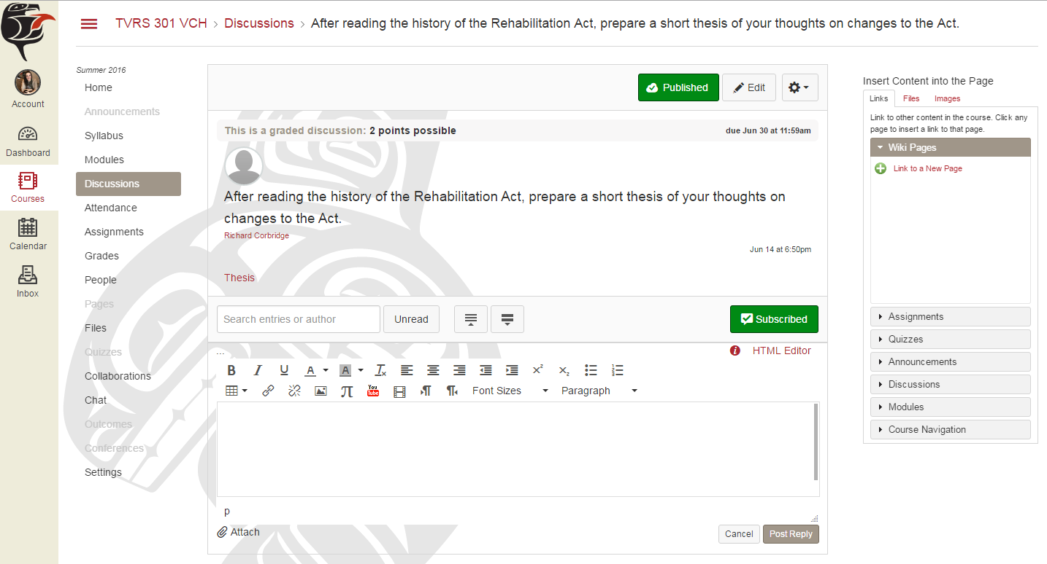
- A text box will appear where you can type your answer to the discussion prompt, or attach a file.
You can type your response here, or attach a file below.
- When you’re done, simply push ‘Post Reply’ at the bottom right.
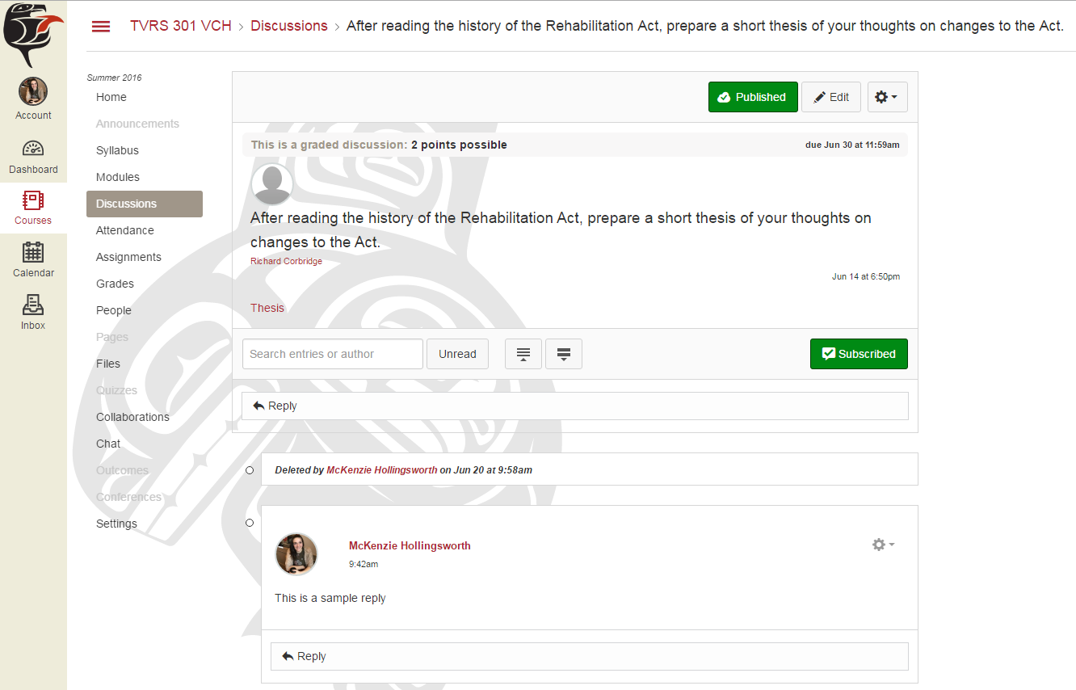
- Sometimes, you will also have to reply to other students’ answers in the discussion. To do this, simply push the ‘Reply’ button under the other students’ post, not the one under the main discussion thread!
Canvas Inbox
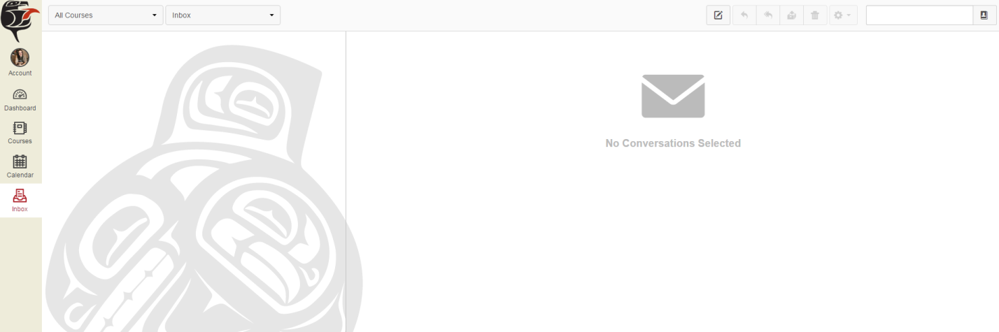
- You can receive and send messages to your instructors and other students right in Canvas! To use this feature, just click on ‘Inbox’ on the left of your screen.
- Newest messages will appear at the top on the left side, and a blue dot will appear to the left of messages you haven’t read yet. Clicking on a message will open it on the right. To create a new message, click this button:
Grades
- To look at your grades for a class, select ‘Grades’ on the left of your screen.
- All your grades for that class, with the oldest on the top and the newest on the bottom, will appear.
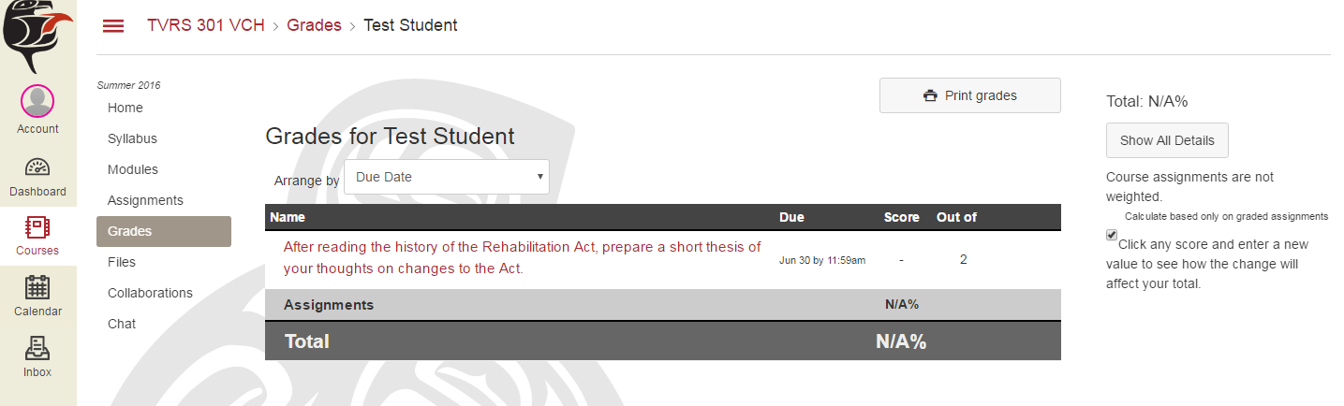
- Your percentage for the class (for example, 85%) will be on the right side of your grades.
Quizzes
- You can look at quizzes in a class by selecting it on the left side of your screen. All quizzes for your class will appear, along with its availability and due date.
- If a quiz says ‘Closed’, that means the due date has already passed.
- If it says ‘Available’, that means you can still take the quiz.
- If it says ‘Not available until…’, then you must wait until the date it says before you can take that quiz.
- To take a quiz, just click on the quiz title you want and push ‘Take the Quiz’.
Videos / Lectures
- The TVR Institute now uses a video/phone system called ‘Go To Training’ so you can easily watch and listen to live lectures from your instructor. A guide on how to access Go To Training is available on our website’s resources page.
For more information on how to use Canvas…
- Go to https://community.canvaslms.com/community/answers/guides
- If you’re a student, click on ‘Student Guides’
- You can also click on ‘Video Guides’, scroll down to ‘Students’, and there are plenty of videos to help you!
- For more help, call the TVR Institute’s Participant Coordinator McKenzie Hollingsworth at (360) 392-4317.

